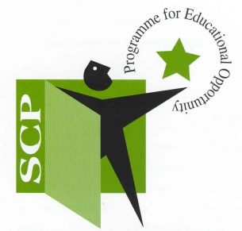

**Kerry South School Completion Programme**

**Invites applications for the post of**

**Project Worker: Part-Time – 20 hours**

**Place of work:** Kerry South SCP cluster schools’ catchment area, based between Castleisland and Tralee urban areas

**Employment Type**: Fixed term 24-25

**Salary**: CDYSB Youth Work Scale 2023

The School Completion Programme (SCP) is a Tusla funded programme that aims to have a significant positive impact on levels of children and young peoples’ attendance, engagement and retention in primary and second level schools and on numbers of pupils who successfully complete the Senior School Cycle, or equivalent.

The ideal candidate should have the following:

* Minimum Level 7 Qualification in one of the following: education/teaching, youth/community work, social care/science or a related discipline.
* Minimum of two years post graduate paid work in provision of services for children/young people at risk.
* A thorough knowledge of the Irish education system and ability to plan, implement and evaluate educational, developmental and recreational programmes for individuals and groups of students in primary and post primary education.
* Experience of working with children and young people in a mentoring capacity; one to one, and in group settings.
* Skills and talents that are transferrable to developing programmes that will engage students at risk of early school leaving.
* Experience of facilitating evidence-based/informed programmes for children and young people is desirable.
* Excellent communication planning, organisational, networking and report writing skills.
* A full, clean driving license and own transport essential.

Please see Job Description for more information.

In accordance with The National Vetting Bureau (Children and Vulnerable Persons) E vetting will be a requirement for the successful candidate. Tusla Children First Certification is a pre-requisite.

Probationary period will apply.

Application form and job description for this post may be obtained from www.kerryetb.ie/opportunities.

Please complete application form and return by email only to [jobs@kerryetb.ie](mailto:jobs@kerryetb.ie). No CVs, only official application form will be accepted. Application must be received not later than Monday 10th March 2025

Application is by way of application form, completed forms to be emailed to jobs@kerryetb.ie

* Short listing will apply and only short listed candidates will be contacted.
* Cover letters, CVs and incomplete application forms will NOT be accepted.