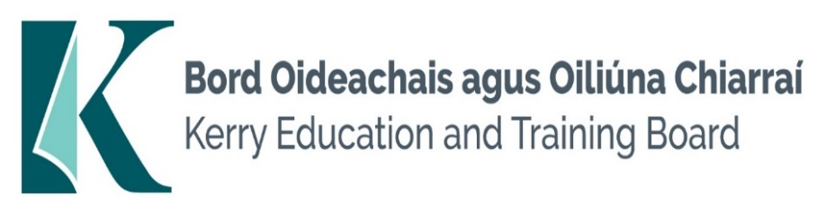

**Job Description: Rúnaí Scoile**

**Position Title:** Office Admin - School Secretary

**Location:** Gaelcholáiste Chiarraí – Scoil iarbhunscoile Lán Gaeilge

**Reports To:** School Principal

**Salary**

Salary Scale and Conditions of Service will be in accordance with the regulations of the Department of Education.

**Job Summary:** The School Secretary is a vital member of the school community, responsible for providing administrative support, managing school resources, and ensuring a safe and efficient workplace. This role serves as the first point of contact for parents, students, and the public, and supports the school leadership team in maintaining smooth operations.

**Key Responsibilities:**

1. **Receptionist Duties:**
   * Greet and assist visitors, parents, and students in a friendly and professional manner.
   * Answer and direct phone calls, emails, and other inquiries to the appropriate staff members.
   * Maintain a welcoming and organized reception area.
2. **Handling Queries:**
   * Address and resolve queries from parents, students, and the public promptly and efficiently.
   * Provide information about school policies, procedures, and events.
3. **First Point of Contact:**
   * Serve as the initial point of contact for all visitors and inquiries.
   * Ensure a positive and professional image of the school is maintained at all times.
4. **Maintaining a Safe Workplace:**
   * Ensure the office and school environment are safe and comply with health and safety regulations.
   * Report any safety concerns to the appropriate personnel.
5. **Resource Management:**
   * Manage and monitor school resources, ensuring adequate office and classroom supplies.
   * Record and track the delivery of stock and supplies.
   * Liaise with the purchasing unit to ensure timely ordering, delivery, and payment for orders placed.
6. **Attendance Management:**
   * Monitor and record student attendance daily.
   * Manage the comings and goings of students, ensuring accurate records are maintained.
   * Communicate with parents regarding student absences and attendance issues.
7. **Administrative Support:**
   * Assist the school leadership team with administrative tasks to ensure the school runs smoothly.
   * Prepare and distribute school communications, such as newsletters and notices.
   * Maintain and update school records and databases.
8. **General Office Duties:**
   * Organize and maintain filing systems, both electronic and physical.
   * Schedule and coordinate meetings, appointments, and events.
   * Perform other related duties as assigned by the school leadership team.

**Working Conditions:**

* Temporary position, typically during school hours with occasional after-hours work for events or meetings.
* Office environment within a school setting.
* The school is an Irish language school and while it is desirable that the successful candidate would be fluent, the minimum requirement would be that the candidate is expected to have working proficiency in Irish and if not currently proficient, is expected to be able to improve their standard of Irish in the short term.

**Eligibility Criteria**

**Candidates must (as per Circular 8/2017):**

* have the requisite knowledge, skills and competencies to carry out the role
* be capable and competent of fulfilling the role to a high standard
* have obtained at least Grade D3 in five subjects in the Leaving Certificate Examination (higher, ordinary, applied or vocational programmes) or equivalent or have passed an examination at the appropriate level within the QQI qualifications framework which can be assessed as being of a comparable to Leaving Certificate standard or equivalent or higher or have appropriate relevant experience which encompasses equivalent skills and expertise
* be at least 17 years of age on or before the date of advertisement of the recruitment competition

Citizenship RequirementCandidates should note that eligibility to compete for posts is open to citizens of the European  
Economic Area (EEA) or to non-EEA nationals with a valid work permit. The EEA consists of  
the Member States of the European Union along with Iceland, Liechtenstein and  
Norway. Swiss citizens under EU agreements may also apply.

Health & Character

Those under consideration for a position may at the discretion of the employer be required  
to complete a health and character declaration and a Garda Vetting form. References will be  
sought.

**Desirable Criteria**

* Achieved or be at an advanced stage of working towards a Level 6 qualification or higher in a relevant area
* Excellent administrative and IT Skills
* Proven experience in a similar administrative role, preferably in an educational setting
* Strong organisational and multitasking abilities.
* Excellent communication and interpersonal Skills
* Proficiency in Microsoft Office Suite and other relevant software.
* Ability to handle sensitive information with confidentiality and discretion.

**Person Specification**

**Competences Required**

Kerry ETB Core Values of Respect, Quality, Equality, Inclusion and Excellence in Learning are the guiding principles of the organisation and underpin the competencies required to fulfil this role.

The person appointed to the above post will be required to show evidence of the following competences:

**Team Work**

* Show respect for colleagues and co-workers
* Develops and maintains good working relationships with others, sharing information and knowledge, as appropriate
* Offers own ideas and perspectives
* Understands own role in the team, making every effort to play his/her part

**Information Management and Decision Making**

* Approaches and delivers all work in a thorough and organised manner
* Follows procedures and protocols, understanding their value and the rationale behind them
* Keeps high quality records that are easy for others to understand
* Draws appropriate conclusions from information
* Suggests new ways of doing things better and more efficiently
* Is comfortable working with different types of information, e.g. written, numerical, charts and carries out calculations such as arithmetic, percentages etc.

**Delivery of Results**

* Takes responsibility for own work and sees it through to the appropriate next level
* Completes work in a timely manner
* Adapts quickly to new ways of doing things
* Checks all work thoroughly to ensure it is completed to a high standard and learns from mistakes
* Writes with correct grammar and spelling and draws reasonable conclusions from written instructions
* Identifies and appreciates the urgency and importance of different tasks
* Demonstrates initiative and flexibility in ensuring work is delivered
* Is self-reliant and uses judgement on when to ask a manager or colleagues for guidance

**Customer Service and Communication Skills**

* Actively listens to others and tries to understand their perspectives/requirements/needs
* Understands the steps or processes that customers must go through and can clearly explain these
* Is respectful, courteous and professional, remaining composed, even in challenging circumstances
* Can be firm when necessary and communicate with confidence and authority
* Communicates clearly and fluently when speaking and in writing

**Specialist Knowledge, Expertise and Self Development**

* Develops and maintains the skills and expertise required to perform in the role effectively, e.g. relevant technologies, IT systems, relevant policies etc.
* Clearly understands the role, objectives and targets and how they fit into the work of the unit
* Is committed to self-development and continuously seeks to improve personal performance

**Drive & Commitment to Public Service Values**

* Consistently strives to perform at a high level and deliver a quality service
* Is thorough and conscientious, even if work is routine
* Demonstrates resilience in the face of significant demands and challenges
* Ensures that the customer is at the heart of all services provided
* Is personally honest and trustworthy
* Acts with integrity and supports this in others