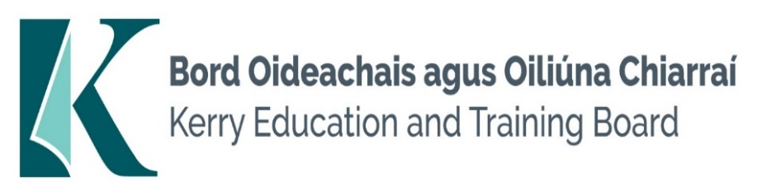

**Job Description: Glantóir Scoile**

**Position Title:** School Cleaner Part time (12 hours per week)

**Location:** Gaelcholáiste Chiarraí – Scoil lán Ghaeilge

**Reports To:** School Principal

**Job Summary:** The School Cleaner is responsible for maintaining a clean, safe, and hygienic environment within the school premises. This role ensures that all areas of the school are kept in excellent condition, contributing to a positive and healthy learning environment for students and staff. A strong emphasis is placed on adhering to health and safety standards.

**Key Responsibilities:**

1. **Cleaning Duties:**
   * Clean and sanitize classrooms, offices, restrooms, hallways, and other school areas.
   * Sweep, mop, vacuum, and polish floors.
   * Dust and wipe down surfaces, including desks, chairs, and equipment.
   * Empty and dispose of trash and recycling bins.
2. **Maintenance of Cleaning Supplies:**
   * Monitor and restock cleaning supplies and equipment.
   * Report any shortages or needs for additional supplies to the Facilities Manager.
   * Ensure cleaning equipment is properly maintained and stored.
3. **Health and Safety:**
   * Follow health and safety guidelines to ensure a safe working environment.
   * Use cleaning chemicals and equipment safely and according to instructions.
   * Report any hazards, damages, or maintenance issues to the Facilities Manager.
4. **Special Cleaning Projects:**
   * Assist with special cleaning projects, such as deep cleaning during school breaks.
   * Clean up spills and respond to emergency cleaning needs promptly.
5. **Collaboration:**
   * Work collaboratively with other cleaning staff and school personnel.
   * Communicate effectively with the Facilities Manager and other team members.
6. **General Duties:**
   * Lock and unlock school buildings as required.
   * Assist with setting up and cleaning up for school events and activities.
   * Perform other related duties as assigned by the Facilities Manager.

**Qualifications:**

* Previous experience in a cleaning role is preferred.
* Knowledge of cleaning chemicals, proper storage, and disposal methods.
* Ability to work independently and as part of a team.
* Strong attention to detail and a commitment to maintaining high standards of cleanliness.
* Good communication skills and the ability to follow instructions.
* Awareness of health and safety regulations and the ability to adhere to them.

**Working Conditions:**

* Temporary position, with hours typically outside of regular school hours.
* Physical demands include standing, walking, bending, and lifting.
* Awareness of health and safety regulations and the ability to adhere to them.

**Person Specification**

**Essential Requirements:**

* Proven experience of undertaking cleaning duties
* Experience of using buffing and vacuuming equipment
* Working knowledge and familiarity with commercial cleaning techniques
* Good organisational and time management skills
* Flexible with the ability to deal with unexpected events and changing work activities
* Willingness to work outside normal hours as required
* Experience and understanding of Health and Safety
* Punctual, reliable and trustworthy

**Desirable Requirements:**

* Ability to work effectively and supportively as a member of the school/college team
* Good interpersonal and communication skills
* Ability to act on own initiative

Short listing will take place on the basis of evidence provided in the application form.

**The person appointed will be required to show evidence of the following:**

**Specialist Knowledge & Expertise:**

* Is committed to self-development including further training if required and continuously seeks to improve personal performance
* Proven experience of undertaking cleaning duties.
* Experience of using buffing and vacuuming equipment
* Working knowledge and familiarity with commercial cleaning techniques
* Ability to follow manufacturers’ instructions with regard to cleaning equipment and chemical usage

**Knowledge of Health and Safety:**

* Experience and understanding of relevant Health and Safety issues

**Team Work:**

* Show respect for colleagues and co-workers
* Ability to work effectively and supportively as a member of the school team
* Offers own ideas and perspectives
* Understands own role in the team, making every effort to play his/her part

**Customer Service and Communication Skills:**

* Actively listens to others understanding their perspectives/requirements/needs
* Communicates clearly and concisely when speaking and in writing
* Ability to follow instructions on equipment, materials etc.
* Good interpersonal and communication skills

**Delivery of Results:**

* Completes work in a timely manner
* Adapts quickly to new ways of doing things
* Checks all work thoroughly to ensure it is completed to a high standard
* Identifies and appreciates the urgency and importance of different tasks
* Punctual, reliable and trustworthy

**Drive & Commitment to Public Service Values:**

* Consistently strives to perform at a high level and deliver a quality service
* Is thorough and conscientious, even if work is routine
* Demonstrates resilience in the face of significant demands and challenges
* Ensures that the learner is at the heart of all services provided
* Is personally honest and trustworthy
* Acts with integrity and supports this in others

Kerry ETB Core Values of Respect, Quality, Equality, Inclusion and Excellence in Learning are the guiding principles of the organisation and underpin the competencies required to fulfil this role.