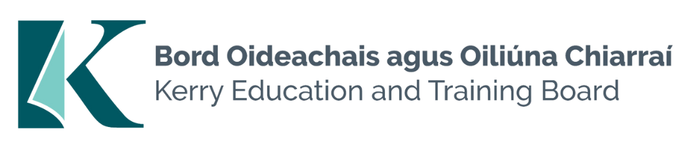

Job Description and Person Specification
Grade III Clerical Officer – Specific Purpose
Kerry Education & Training Board

Location
Appointment is to the Scheme – Kerry ETB reserves the right to assign a staff member to any location, as the service exigencies require. Centre of first assignment: Kerry College, Monavalley Campus.

Reporting/Accountability Relationship
Grade III Clerical Officers will report to relevant Campus Manager

Salary
Salary Scale and Conditions of Service will be in accordance with the regulations of the Department of Further and Higher Education, Research, Innovation and Science.

Post Summary/Purpose
The appointees may be assigned to any of a very wide variety of areas or activities carried out in the Kerry ETB Scheme.

Duties

- To carry out the duties of a Clerical Officer under the supervision of a designated line manager
- To carry out general clerical duties e.g. manual and electronic filing, photocopying, answering/making telephone calls, dealing with e-mails etc.
- To assist in the drafting and issue of letters, memos and general information to staff/learners/public, as required.
- To assist in the implementation of organisational work activities and supporting line managers and colleagues
- To be responsible for general administration and administrative efficiency of the assigned area.
- To maintain spreadsheets, databases etc. to produce management information that is accurate, reliable and available for departmental/organisational decision making
- To keep such records appropriate to the post as may be required by the wider team and management
- To ensure high quality customer service in dealing with the public/learners/staff etc. e.g. responding to queries and providing information effectively and efficiently
- Use of Information Technology e.g. software relevant to the area of work, word processing, spreadsheets, database, e-mail and internet etc.
- To draft relevant correspondence as required e.g. letters, memos etc.
- Processing incoming and outgoing post (where required).
- To arrange meetings and take minutes as required.
- To work as part of a team in delivering services
- Liaise with staff in other schools/centres/departments, the public and outside agencies in a confidential, courteous and professional manner.
- Ensure all information received within the school/centre/department remains confidential.
- Maintain a strong focus on self-development, seeking feedback and opportunities for growth.
- Report any breaches or suspected breaches relating to Governance Systems to the relevant person.
- Comply with Kerry ETB Policies and Procedures.
- Research issues thoroughly to gather information needed in consultation with relevant line manager.
- Plan and prioritise work in terms of importance, timescales and other resource constraints, re-prioritising in consultation with relevant line manager.
- Carry out lawful orders of the Chief Executive.
- Carry out any other duties appropriate to the grade which may be assigned from time to time.
- Liaising with Purchasing Unit in relation to submission of Request to Purchase forms.
- The recording and maintaining of student information on Department of Education database.
- Taking reasonable care to protect the health and safety of yourself and other people in the workplace.

Person Specification

Eligibility Criteria
Candidates must (as per Circular 8/2017):
- have the requisite knowledge, skills and competencies to carry out the role
- be capable and competent of fulfilling the role to a high standard
- have obtained at least Grade D3 in five subjects in the Leaving Certificate Examination (higher, ordinary, applied or vocational programmes) or equivalent or have passed an examination at the appropriate level within the QQI qualifications framework which can be assessed as being of a comparable to Leaving Certificate standard or equivalent or higher or have appropriate relevant experience which encompasses equivalent skills and expertise
- be at least 17 years of age on or before the date of advertisement of the recruitment competition

Citizenship Requirement
Candidates should note that eligibility to compete for posts is open to citizens of the European
Economic Area (EEA) or to non-EEA nationals with a valid work permit. The EEA consists of
the Member States of the European Union along with Iceland, Liechtenstein and
Norway. Swiss citizens under EU agreements may also apply.
Health & Character
Those under consideration for a position may at the discretion of the employer be required
to complete a health and character declaration and a Garda Vetting form. References will be
sought.

Desirable Criteria
- Achieved or be at an advanced stage of working towards a Level 6 qualification or higher in a relevant area
- Excellent administrative and IT Skills
- Excellent communication and interpersonal Skills
- Ability to prioritise and manage work in a dynamic and fast paced environment
- Proven record as a team player
- Understand the main features and current challenges of public service
- Experience of the education and/or training sector

Competences Required
Kerry ETB Core Values of Respect, Quality, Equality, Inclusion and Excellence in Learning are the guiding principles of the organisation and underpin the competencies required to fulfil this role.

The person appointed to the above post will be required to show evidence of the following competences:
Team Work
- Show respect for colleagues and co-workers
- Develops and maintains good working relationships with others, sharing information and knowledge, as appropriate
- Offers own ideas and perspectives
- Understands own role in the team, making every effort to play his/her part

Information Management and Decision Making
- Approaches and delivers all work in a thorough and organised manner
- Follows procedures and protocols, understanding their value and the rationale behind them
- Keeps high quality records that are easy for others to understand
- Draws appropriate conclusions from information
- Suggests new ways of doing things better and more efficiently
- Is comfortable working with different types of information, e.g. written, numerical, charts and carries out calculations such as arithmetic, percentages etc.

Delivery of Results
- Takes responsibility for own work and sees it through to the appropriate next level
- Completes work in a timely manner
- Adapts quickly to new ways of doing things
- Checks all work thoroughly to ensure it is completed to a high standard and learns from mistakes
- Writes with correct grammar and spelling and draws reasonable conclusions from written instructions
- Identifies and appreciates the urgency and importance of different tasks
- Demonstrates initiative and flexibility in ensuring work is delivered
- Is self-reliant and uses judgement on when to ask a manager or colleagues for guidance

Customer Service and Communication Skills
- Actively listens to others and tries to understand their perspectives/requirements/needs
- Understands the steps or processes that customers must go through and can clearly explain these
- Is respectful, courteous and professional, remaining composed, even in challenging circumstances
- Can be firm when necessary and communicate with confidence and authority
- Communicates clearly and fluently when speaking and in writing

Specialist Knowledge, Expertise and Self Development
- Develops and maintains the skills and expertise required to perform in the role effectively, e.g. relevant technologies, IT systems, relevant policies etc.
- Clearly understands the role, objectives and targets and how they fit into the work of the unit
- Is committed to self-development and continuously seeks to improve personal performance

Drive & Commitment to Public Service Values
- Consistently strives to perform at a high level and deliver a quality service
- Is thorough and conscientious, even if work is routine
- Demonstrates resilience in the face of significant demands and challenges
- Ensures that the customer is at the heart of all services provided
- Is personally honest and trustworthy
- Acts with integrity and supports this in others

