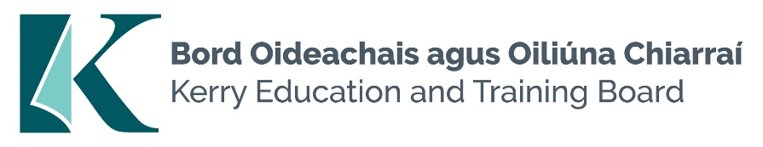

**Part-Time Adult Educator**

**Job Description**

**Hours of Work:**

This is a part-time position for the specific purpose of delivering part-time provision. Hours of work will be 10 hours of course delivery per week and 7.5 hours of administration.

**Reporting/Accountability Relationships**

Reporting to the Centre Manager/AEO

**Nature of Post**

Delivery of Art related QQI courses in in North Kerry.

Ceramics and Pottery being the main subject areas required.

**Areas of Responsibility**

Under general supervision, the purpose of the position is to deliver education and training to adults in part-time learning.

## Duties and Responsibilities will include:

* Instruct course participants in designated areas to certified standards as required;
* Ensure all learners are inducted into health and safety before they commence practical training;
* Prepare lesson plans, course notes, presentational material, and handouts as appropriate;
* Schedule assessments in accordance with the relevant assessment programmes and carry out associated administrative tasks;
* Provide appropriate additional instruction and schedule repeat assessments in accordance with the prescribed referral procedure;
* Maintain prescribed course records and learner register of attendance;
* Ensure all learners adhere to health and safety requirements.;
* Supervise learners and ensure that correct methods, quality standards and safety procedures are observed;
* Supervise learners in respect of their timekeeping, attendance, behaviour, and general application of the learners to the course;
* Plan and ensure the timely delivery of all course material;
* Raise requests for the purchase and supply of course material;
* Ensure that course materials are used in an economical and cost-effective manner;
* Use new technology as appropriate, to assist in delivering and administering training;
* Undertake such other duties as may be assigned from time to time.

**Essential Requirements**

* Relevant Technical qualification
* Extensive knowledge relevant to the area of work;
* Have sufficient confidence in his/her ability to transfer the skills of the occupation as specified in the relevant curriculum/programme specification;
* Ability to deliver training modules to a wide range of learning abilities;
* Ability to assess the learner’s progress in training;
* Ability to self-assess their effectiveness in transfer of skills and knowledge to the learner;
* Articulate, with the ability to communicate the relevant course information in a manner designed to motivate the learner;
* Be well motivated for delivery of training programmes;
* Possess the necessary coping skills to deal with conflict, motivational and disciplinary problems associated with training;
* Excellent oral and written communication skills;
* Ability to provide constructive feedback;
* Excellent ICT and administration skills;
* Full clean driving licence and access to a car;

**The following would be advantageous:**

* Degree in Fine Art
* A qualification at Level 7 on the National Framework of Qualifications or its equivalent, in relevant discipline(s) commensurate with this role would be a decided advantage;
* Or 3 years experience in choosen area of discipline
* Previous training, instructing, or teaching experience;
* Ability to work as part of a team;
* Good knowledge of Kerry ETB activities.

**COMPETENCIES REQUIRED**

A number of key competencies have been identified as being essential for the effective performance of the role and function of this position

These competencies are as follows:

* Specialist Knowledge, Expertise and Self Development;
* Teaching/Instructing/Training ability;
* Specific capacity to contribute to the overall needs of the Further Education and Training Services;
* Management and Delivery of Results;
* Professional Development.