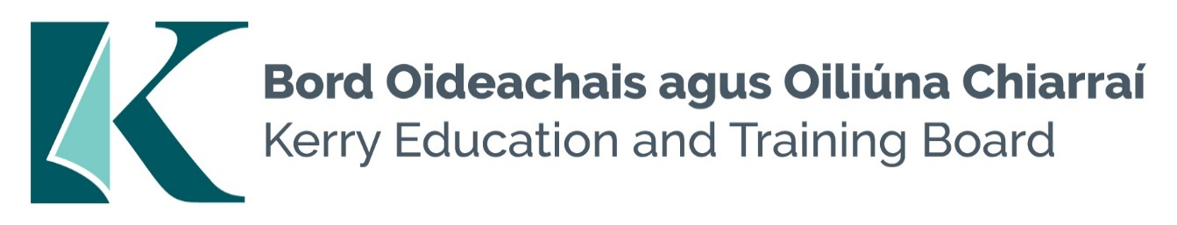

**Permanent Principal Post:**

**Coláiste Gleann Lí (Roll No. 70550H)**

**Category XIII Principal Allowance**

**Permanent Principal Post:**

**Castleisland Community College (Roll No. 70520V)**

**Category XII Principal Allowance**

Kerry Education and Training Board invites applications for the posts of Permanent Principal for **Coláiste Gleann Lí, Tralee** and **Castleisland Community College**. These senior management posts will afford the appointee an opportunity to lead teams to deliver and enhance quality education services in the Kerry area and to participate as a member of the senior management team in Kerry Education and Training Board.

**To qualify for appointment candidates must have:**

* A recognised post-primary teaching qualification.
* A minimum of 5 years’ satisfactory teaching experience or equivalent.
* Registration in accordance with Section 30 of the Teaching Council Act 2001.
* A proven track record in Curriculum Leadership and Change Management.
* Evidence of commitment to the core values of Kerry Education and Training Board: respect, quality, equality, inclusion and excellence in learning

*Colm Mc Evoy*

*Chief Executive Officer*

-------------------------------------------------------------------------------------------------------------------------------------------

Conditions of Service, Terms of Appointment, Qualifications, Salary Scales and Allowances are in accordance with the regulations of the Department of Education.

Please complete an application form and **return by email only** to [jobs@kerryetb.ie](mailto:jobs@kerryetb.ie). No C.V.’s, only official application form will be accepted. Applications must be received not later than **12 noon Monday 18th November 2024.**

**Kerry Education & Training Board services Gaeltacht areas.**

**Cuirfear fáilte roimh chomhfhreagras i nGaeilge.**

**Garda Vetting of successful candidates will take place prior to offer of employment.**

**Canvassing will automatically disqualify.**

**Short-listing will take place on the basis of the information provided in the application form. Depending on the qualifications and experience of applicants, short-listing thresholds may be significantly higher than the minimum standards set out.**

###### Kerry Education & Training Board is an equal opportunities employer.

***“Building your future”***

