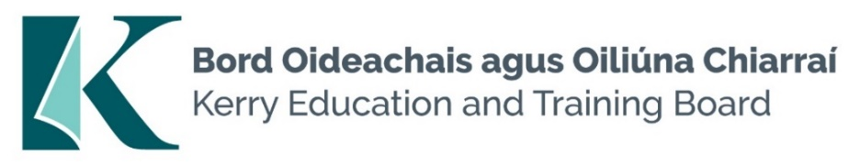

**Kerry Education and Training Board Committee Vacancies**

**Audit and Risk CommitteeFinance CommitteeGuidelines**

**Background information**

Kerry Education and Training Board (Kerry ETB) was established on July 1st 2013 and is the statutory agency based in Kerry for the provision of Primary, Post Primary and Further Education and Training opportunities in County Kerry.

Kerry ETB delivers its Education and Training Programmes from circa 38 Schools/Centres and over 100 Outreach centres across the county. The ETB has an annual budget of circa €81 million employing circa1,400 staff with approximately 16,000 students/learners annually.

**Introduction**

Kerry ETB currently is in the process of establishing an Audit and Risk Committee and Finance Committee as per *Section 45* of the *Education and Training Boards Act 2013*. Each Committee will be comprised of Kerry ETB Board Members and External Member (s).

Provision has been made for:

1. 4 external appointees to the Finance Committee
2. 4 external appointees to the Audit and Risk Committee

**Function**

Both the Audit and Risk Committee and Finance Committee have specific roles, separate and independent of executive management, in assisting the Board of Kerry ETB in discharging its functions.

Each Committee must advise the Board in relation to the performance of its functions and ensure that the interests of all stakeholders are fully protected in relation to business and financial reporting and internal controls.

**Appointment**

Appointments to each Committee will be made by the Board of Kerry ETB.

All members appointed to each Committee will be provided with a formal induction and continuing support and training in relevant matters as appropriate.

**Finance Committee**

**Relevant Skills and Experience:**

Members of the Audit and Risk Committee should have experience in and/or knowledge of:

* Financial Practices;
* Corporate Governance;
* Risk Management;
* Internal & External Audit
* Public Sector Environment

Members should also have, or acquire as soon as possible after their appointment, an understanding of;

* the functions of an ETB;
* organisational culture, objectives and challenges;
* organisational structure including key relationships, e.g. the ETB’s relationship with the Minister, the Department of Education and Skills and other funding agencies/Departments;
* relevant legislation and other rules governing the financial operations of the ETB.

The Finance Committee should collectively possess an appropriate range of skills to perform its functions to the required standard. Members should have a thorough understanding of the role of the Finance Committee and financial experience. Competencies:

**Duration of Appointment:**

The duration of appointment of Finance Committee members is for is for the term of the Kerry ETB Board i.e. 2024 – July 2029 (5 years).

**Frequency of Meetings**

The Finance Committee should meet at least four times a year and invite outsiders with relevant experience to attend meetings if necessary as per *Section 45(3) of the Education and Training Board Act 2013*

**Conflict of Interest:**

Each member of the Finance Committee should take personal responsibility to declare any potential conflict of interest arising in relation to any items on the agenda for Finance Committee meetings.

All members appointed to the Finance Committee will be required to sign the Code of Conduct for Members.

**Expression of Interest**

Any person wishing to be considered for appointment to the aforementioned Committee must submit an *Expression of Interest form* to [jobs@kerryetb.ie](mailto:jobs@kerryetb.ie)

Closing date for expression of interest is no later than 12 noon Monday 25th November 2024.

**Audit and Risk Committee**

**Relevant Skills and Experience:**

Members of the Audit and Risk Committee should have experience in and/or knowledge of:

* Finance/Accounting;
* Corporate Governance;
* Risk Management;
* Internal Audit;
* Relevant technical or specialist issues and
* Public Sector Environment.

Members should also have, or acquire as soon as possible after their appointment, an understanding of;

* the functions of an ETB;
* organisational culture, objectives and challenges;
* organisational structure including key relationships e.g. the ETB’s relationship with the relevant Minister and parent Department; and
* relevant legislation or other rules governing the organisation

The Audit and Risk Committee should collectively possess an appropriate range of skills to perform its functions to the required standard. All members of the Audit and Risk Committee should have a thorough understanding of corporate governance and the role of the Audit and Risk Committee.

**Duration of Appointment:**

The duration of appointment of Audit and Risk Committee members is for the term of the Kerry ETB Board i.e. 2024 – July 2029 (5 years).

**Frequency of Meetings**

The Audit and Risk Committee should meet at least four times a year and invite outsiders with relevant experience to attend meetings if necessary as per *Section 45(3) of the Education and Training Board Act 2013*

**Conflict of Interest:**

Each member of the Audit and Risk Committee should take personal responsibility to declare any potential conflict of interest arising in relation to any items on the agenda for Audit and Risk Committee meetings.

All members appointed to the Audit and Risk Committee will be required to sign the Code of Conduct for Members.

**Expression of Interest**

Any person wishing to be considered for appointment to the aforementioned Committee must submit an *Expression of Interest form* to [jobs@kerryetb.ie](mailto:jobs@kerryetb.ie)

Closing date for expression of interest is no later than 12 noon Monday 25th November 2024.