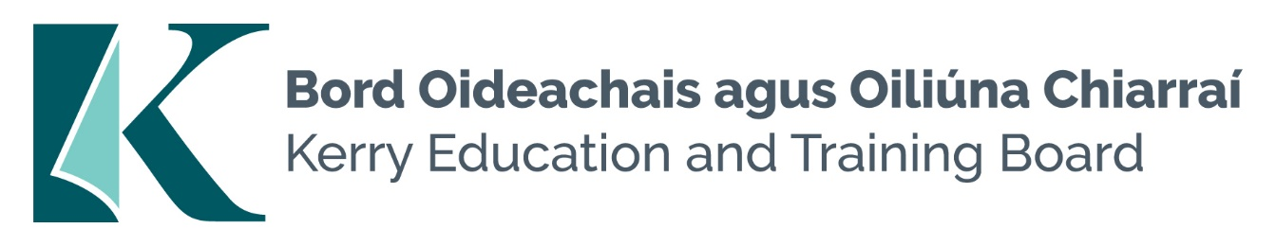

Candidates should possess:
- Fluent spoken Irish and a high standard of written Irish are required for this job.
- Good Organisational, communication and interpersonal skills
- Familiarity with Second level curriculum.
- Ability to support and enhance educational experience for children with Special Educational Needs (SEN) who present in Kerry Education and Training Board Schools.
- A commitment to creating a safe supported environment for students with SEN needs
- A good understanding of recent developments in SEN in Ireland particularly the legislation as it pertains to the Education for persons with SEN Act 2004.
- TUSLA Child First Training – Certificate of completion
- Current First Aid Responder Certification
- Current Manual Handling Certification

Desirable:
- Completed QQI Level 5 Full Award or equivalent in childcare or equivalent Special Needs qualification
- Medical/Healthcare experience
- Excellent ICT Skills
- Competency in the use and understanding of Sign Language

