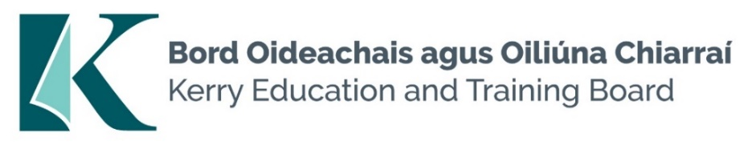

**Kerry Education and Training Board Committee Vacancies**

Kerry Education and Training Board (Kerry ETB) is establishing Committees of the Board as per *Section 45* of the *Education and Training Boards Act 2013*.

The Board of Kerry ETB is seeking expressions of interest for consideration for appointment to

(1) Audit and Risk Committee

(2) Finance Committee.

Provision has been made for:

1. Four external appointees to the Audit and Risk Committee
2. Four external appointees to the Finance Committee

Experience and/or knowledge of financial practices, corporate governance, risk management, internal audit and public sector bodies are desirable.

A fee is payable to appointees as per Department of Education and Skills guidelines (2015).

Further details are available on the Kerry ETB website.

Expression of Interest Forms should be submitted to [jobs@kerryetb.ie](mailto:jobs@kerryetb.ie) no later than 12 noon, Monday 4th November 2024

**Colm Mc Evoy**

**Chief Executive Officer**

**Kerry ETB**