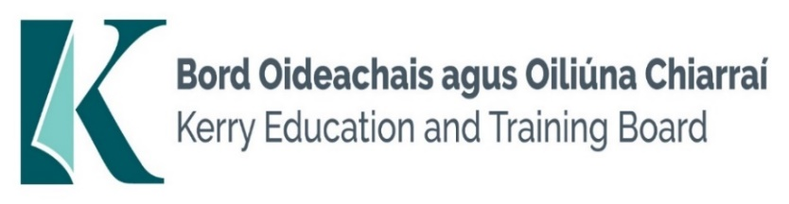

**Job Description**

**Reporting/Accountability Relationship:** Bus Escort will report to Principal/Deputy Principal

**Salary Scale and Conditions of Service:** In accordance with the regulations of the Department of Education.

**JOB DESCRIPTION OF BUS ESCORT**

In addition to the listed duties the Bus Escort will undertake other duties pertaining to the role as may be decided/directed by School Principal/Deputy Principal and/or Kerry Education and Training Board. It is expected that the Bus Escort will on his/her own initiative, identify tasks/duties that need to be carried out as part of the role subject to authorisation by School Principal/Deputy Principal and/or Kerry Education and Training Board as appropriate.

The duties listed are not intended to be exhaustive or exclusive

**The Bus Escort must:**

1. Ensure that s/he is on the school transport at the time of the first pick-up and last set down.
2. Is responsible for the safety of children when opening and closing doors prior to “stop” and “move off”.
3. Assist children to board and alight safely from the school transport.
4. Ensure that all children are seated with appropriate straps and harnesses where provided.
5. Ensure that each pupil is received by some responsible person at the set down point.
6. Supervise the children travelling on the school transport and to and from the school transport into and out of the School/classrooms.
7. Maintain a good working relationship with the driver of the school transport.
8. Act as liaison between the School Principal and/or class teacher and parents when required i.e. conveyance of messages and letters to parents.
9. Observe confidentiality in all aspects of work.
10. Be aware of particular disabilities of children on the school transport and be briefed by the School Principal on how to deal with same i.e. epilepsy etc.
11. Perform any other duties relevant to the position of escort which may be assigned by the School Principal from time to time.
12. Not leave the school transport unless under exceptional circumstances
13. Ensure that his/her position on the school transport is where maximum control of the children is achieved.
14. Report all concerns to the School Principal and/or Class Teacher.
15. Carry out any other duties appropriate to the grade which may be assigned from time to time.

**Person Specification**

**Bus Escort**

**Essential Requirements:**

* Punctual, reliable and trustworthy
* Good organisational and time management skills
* Flexible with the ability to deal with unexpected events and changing work activities
* Willingness to work outside normal hours as required
* Experience and understanding of Health and Safety

**Desirable Requirements:**

* Ability to work effectively and supportively as a member of the school team
* Good interpersonal and communication skills
* Ability to act on own initiative

Short listing will take place on the basis of evidence provided in the application form.

**Competences required**

Kerry ETB Core Values of Respect, Quality, Equality, Inclusion and Learning are the guiding principles of the organisation and underpin the competencies required to fulfil this role.

The person appointed to the above post will be required to show evidence of the following competences:

**Specialist Knowledge & Expertise:**

* Is committed to self-development including further training if required and continuously seeks to improve personal performance

**Knowledge of Health and Safety:**

* Experience and understanding of relevant Health and Safety issues

**Team Work:**

* Show respect for colleagues and co-workers
* Ability to work effectively and supportively as a member of the school team
* Offers own ideas and perspectives
* Understands own role in the team, making every effort to play his/her part

**Customer Service and Communication Skills:**

* Actively listens to others understanding their perspectives/requirements/needs
* Communicates clearly and concisely when speaking and in writing
* Ability to follow instructions
* Good interpersonal and communication skills

**Delivery of Results:**

* Completes work in a timely manner
* Adapts quickly to new ways of doing things
* Punctual, reliable and trustworthy•

**Drive & Commitment to Public Service Values:**

* Consistently strives to perform at a high level and deliver a quality service
* Is thorough and conscientious, even if work is routine
* Demonstrates resilience in the face of significant demands and challenges
* Ensures that the learner is at the heart of all services provided
* Is personally honest and trustworthy
* Acts with integrity and supports this in others