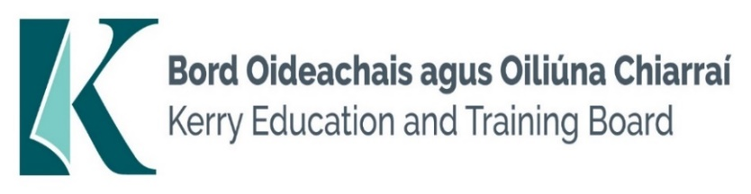

Kerry Education and Training Board (Kerry ETB) is a statutory education and training authority for County Kerry, established in accordance with the provisions of the Education and Training Boards Act 2013.

Kerry ETB is a provider of Primary, Post Primary and Further Education and Training services in Co. Kerry. The ETB has c. 1,388 staff, an annual budget of c. €81 million, c.38 Centres of Education and Training including the Kerry ETB Head Office located in Tralee, Co. Kerry.

**Job Opportunity**

Applications are invited for the following Special Needs Assistant Post which may arise in the school year 2024/2025. All appointments are to Kerry ETB – centre of first assignment is indicated here for the assistance of applicants.

**Two Mile Community National School, Killarney – Full time Special Needs Assistant Post (to cover leave)**

* Experience of working as an SNA in a primary school is essential. Knowledge and understanding of Community National School ethos is essential. Experience of working with children with ASD desirable.

Conditions of Service, Terms of Appointment, details regarding Qualifications and Salary Scale are in accordance with the regulations of the Department of Education.

-------------------------------------------------------------------------------------------------------------------------------------------

Please complete an application form and **return by email only** to [jobs@kerryetb.ie](mailto:jobs@kerryetb.ie)

No C.V.’s, only official application form will be accepted.

Applications must be received not later than **12 noon Monday 16th September 2024.**

*Colm Mc Evoy*

*Chief Executive*

**Kerry Education & Training Board services Gaeltacht areas.**

**Cuirfear fáilte roimh chomhfhreagras í nGaeilge.**

**Garda Vetting of successful candidates will take place prior to offer of employment.**

**Canvassing will automatically disqualify.**

**Short-listing will take place on the basis of the information provided in the application form. Depending on the qualifications and experience of applicants, short-listing thresholds may be higher than the minimum standards set out.**Kerry Education & Training Board is an equal opportunities employer.

*“Building your future”*

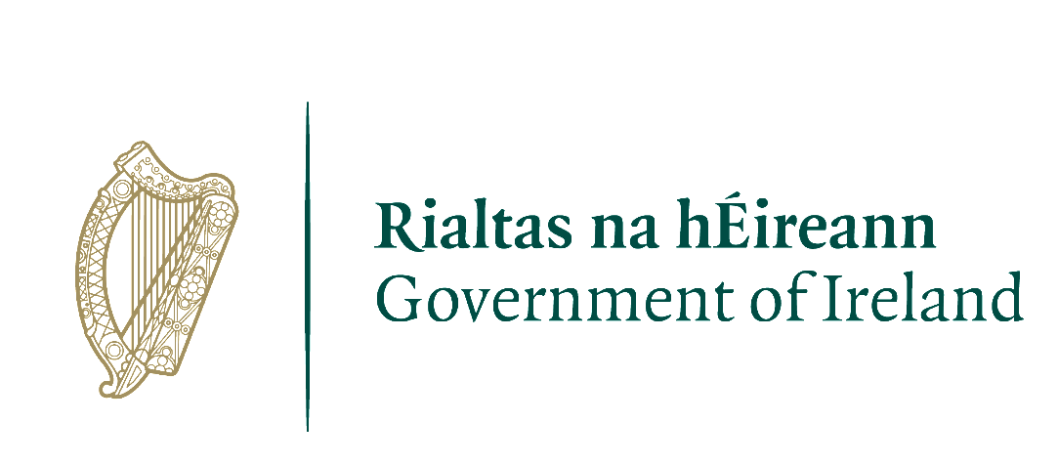cid:image001.png@01DAE345.6925BB60