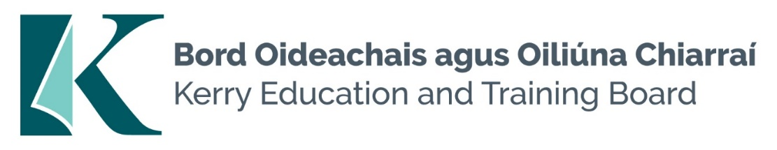

## JOB DESCRIPTION

**Job Title:**  Instructor –Beauty Therapy

**Grade:**  Career Grade

**Reporting To:** Principal/Campus Manager

**Division:** Kerry College, Clash Campus

**Function of Job:** To deliver to trainees all aspects of Beauty Therapy to the prescribed standards and in accordance with the relevant syllabus.

**DUTIES AND RESPONSIBILITIES**

* Instruct the trainees in all aspects of Beauty Therapy i.e. Practical Skills, personal skills, Scientific Skills and all related knowledge to the prescribed standard and in accordance with the relevant syllabus.
* Prepare lesson plans, course notes, overheads and handouts as appropriate.
* Schedule, conduct, correct and mark assessments/tests in accordance with the relevant assessment programme and carry out associated administrative tasks.
* Provide appropriate additional instruction and schedule, conduct, correct and mark repeat assessments programme and carry out administrative tasks.
* Maintain prescribed course records.
* Supervise trainees and ensure that correct methods, quality standards and safety procedures are observed.
* Supervise trainees in respect of their timekeeping, attendance, behaviour and application.
* Ensure adequate security of equipment and materials located in the training area.
* Ensure that equipment and materials are maintained in accordance with the manufacturers recommended maintenance schedule.
* Plan and ensure the timely delivery of all course materials and non-capital equipment.
* Raise Request for Purchase for the supply of course material and non-capital equipment.
* Promote the traineeship format for training delivery to prospective sponsoring employers.
* Ensure participating employers are delivering work based elements of traineeship in the required manner.
* Ensure that course materials are used in an economical and cost effective manner.
* Use new technology, as appropriate, to assist in delivering and administering training.
* Establish and maintain links with industry for the purposes of work placement and attaining employment.
* Research new and upcoming technologies relevant to the Beauty Industry.
* Ability to demonstrate the applicability of Social Media forums in the Beauty Industry.

**Any other duties, which may be specified from time to time.**



## PERSON SPECIFICATION

**Job Title:** Instructor –Beauty Therapy

|  |  |  |
| --- | --- | --- |
|  | **ESSENTIAL** | **DESIRABLE** |
| **MOTIVATION:** | Good knowledge of Kerry ETB  Self Starter/High Initiative.  Previous track record. |  |
|  |
| Knowledge of Post/ |
| Organisation |
| Personal Motivation |
|  |
| Work-Related Achievements |
| **WORK EXPERIENCE:**  Specify Particular  Experience/Skills required. | 5 year post qualification experience over a broad range of related activity. | Teaching or training experience. |
| **COMMUNICATIONS/**  **INTERPERSONAL SKILLS:**  Verbal/Presentation Skills  Writing Skills  Special requirements  Disposition | Strong oral and general communication skills.  Good written ability.  Outgoing personality.  Assertive/Leadership qualities and skills. | Flexible. |
| **EDUCATION:**  General  Technical  Qualifications/Training | ITEC and CIBTAC qualifications  CIBTAC approved | Leaving Certificate  Recognised Train the Trainer qualification |
| **CIRCUMSTANCES/**  **SPECIAL REQUIREMENTS**  **FOR THIS JOB:**  e.g. Travel; Car Owner;  Driving Licence; Unsocial Hours;  Base etc. | Full Drivers Licence. | Live within reasonable distance of Centre. |