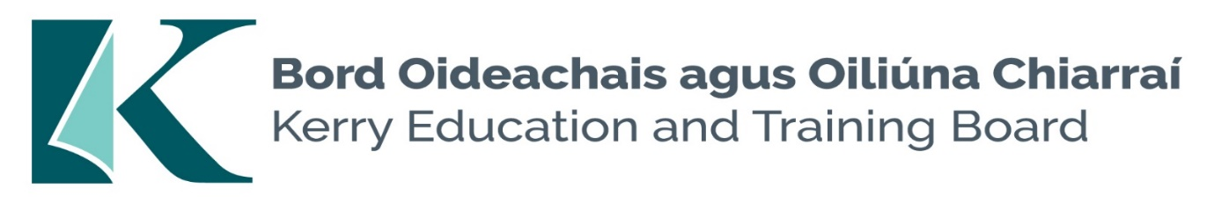

Kerry Education and Training Board (Kerry ETB) is a statutory education and training authority for County Kerry, established in accordance with the provisions of the Education and Training Boards Act 2013.

Kerry ETB is a provider of Primary, Post Primary and Further Education and Training services in Co. Kerry. The ETB has c. 1,388 staff, an annual budget of c. €81 million, c.38 Centres of Education and Training including the Kerry ETB Head Office located in Tralee, Co. Kerry.

Community National Schools Teachers Substitute Pool

Kerry Education & Training Board invites applications for the above Pool. This Pool will be used for the filling of casual part-time teaching posts which may arise at short notice during 2024/2025

------------------------------------------------------------------------------------------------------------------------

Candidates proposed for appointment with Kerry Education & Training Board must be registered in accordance with Section 31 of the Teaching Council Act, 2001.

Applicants are requested to submit confirmation of Teaching Council registration status and proof of current Garda Vetting with their application form.

Please complete application form and return by email only to jobs@kerryetb.ie
No C.V.’s, only official application form will be accepted.

Kerry Education & Training Board services Gaeltacht areas.
Cuirfear fáilte roimh chomhfhreagras í nGaeilge.
Garda Vetting of successful candidates will take place prior to offer of employment.
Canvassing will automatically disqualify.
Short-listing will take place on the basis of the information provided in the application form. Depending on the qualifications and experience of applicants, short-listing thresholds may be higher than the minimum standards set out.

Kerry Education & Training Board is an equal opportunities employer.
“Building your future”

