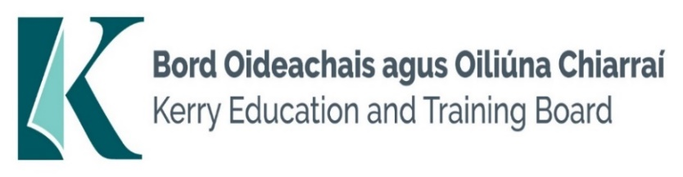

Kerry Education and Training Board (Kerry ETB) is a statutory education and training authority for County Kerry, established in accordance with the provisions of the Education and Training Boards Act 2013.

Kerry ETB is a provider of Primary, Post Primary and Further Education and Training services in Co. Kerry. The ETB has c. 1,388 staff, an annual budget of c. €81 million, c.38 Centres of Education and Training including the Kerry ETB Head Office located in Tralee, Co. Kerry.

**Job Opportunities**

Applications are invited for the following Special Needs Assistant Posts which may arise in the school year 2024/2025. All appointments are to Kerry ETB – centre of first assignment is indicated here for the assistance of applicants.

* **Killorglin Community College  
  Special Needs Assistant Post - (Career Break Cover – full time)**
* **Coláiste na Sceilge**

**Special Needs Assistant Posts (CID (Contract of Indefinite duration) /Fixed Term posts)**

Conditions of Service, Terms of Appointment, details regarding Qualifications and Salary Scale are in accordance with the regulations of the Department of Education.

-------------------------------------------------------------------------------------------------------------------------------------------

Please complete an application form and **return by email only** to [jobs@kerryetb.ie](mailto:jobs@kerryetb.ie)

No C.V.’s, only official application form will be accepted.

Applications must be received not later than **12 noon Thursday 12th September 2024**

**Provisional date for interview: Week of 16th September 2024.**

*Colm Mc Evoy*

*Chief Executive*

**Kerry Education & Training Board services Gaeltacht areas.**

**Cuirfear fáilte roimh chomhfhreagras í nGaeilge.**

**Garda Vetting of successful candidates will take place prior to offer of employment.**

**Canvassing will automatically disqualify.**

**Short-listing will take place on the basis of the information provided in the application form. Depending on the qualifications and experience of applicants, short-listing thresholds may be higher than the minimum standards set out.**Kerry Education & Training Board is an equal opportunities employer.

*“Building your future”*

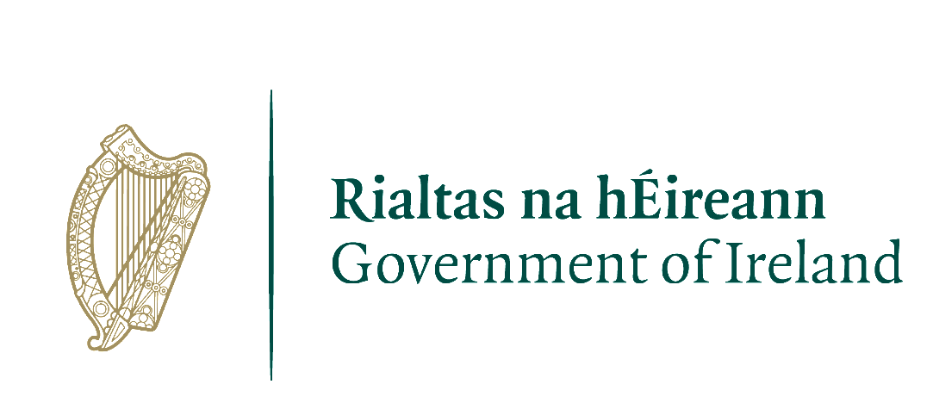cid:image001.png@01DAE345.6925BB60