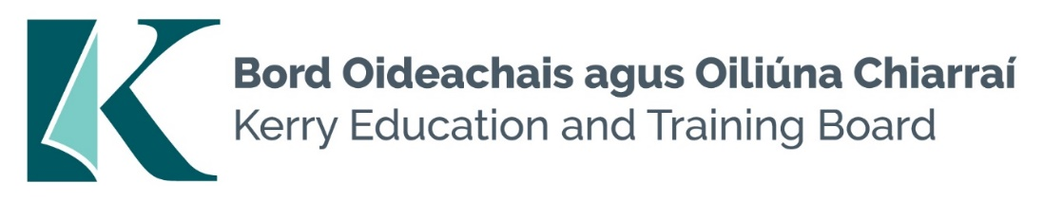

Special Needs Assistant Pool

Candidates should possess:

- Completed QQI Level 5 Full Award in Special Needs Assistant in Childcare/Healthcare/Social Care/Nursing or equivalent qualification
- Organisational, good communication and interpersonal skills
- Familiarity with Second level curriculum.
- Ability to support and enhance educational experience for children with Special Educational Needs (SEN) who present in Kerry Education and Training Board Schools.
- A commitment to creating a safe supported environment for students with SEN needs
- A good understanding of recent developments in SEN in Ireland particularly the legislation as it pertains to the Education for persons with SEN Act 2004.
- Competency in the Irish Language will be a requirement in relevant schools.
- TUSLA Child First Training – Certificate of completion
- Current First Aid Responder Certification
- Current Manual Handling Certification

