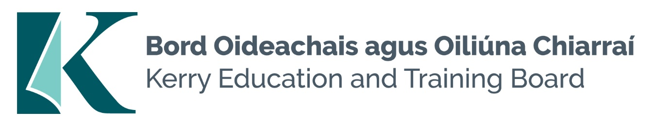

Kerry Education and Training Board (Kerry ETB) is a statutory education and training authority for County Kerry, established in accordance with the provisions of the Education and Training Boards Act 2013.

Kerry ETB is a provider of Primary, Post Primary and Further Education and Training services in Co. Kerry. The ETB has c. 1300, employees, an annual budget of c. €82 million, c.37 Centres of Education and Training with the organisations Head Office located in Tralee, Co. Kerry.

Special Needs Assistant Pool

Applications are invited for the following post(s) under the aegis of Kerry Education & Training Board which may arise. All appointments are to Kerry ETB – centre of first assignment is indicated here for the assistance of applicants.

**Special Needs Assistant Pool**

Centre of first assignment: Covering various Kerry ETB schools in the North and South Kerry areas

Application form and further details ie Job Description and Person Specification are available from our website [www.kerryetb.ie/opportunities.html](http://www.kerryetb.ie/opportunities.html)

-------------------------------------------------------------------------------------------------------------------------------------------

Please complete an application form and return by email only to [jobs@kerryetb.ie](mailto:jobs@kerryetb.ie). No Closing date applies to this pool.

*Colm Mc Evoy*

*Chief Executive*

**Kerry Education & Training Board services Gaeltacht areas.**

**Cuirfear fáilte roimh chomhfhreagras í nGaeilge.**

**Garda Vetting of successful candidates will take place prior to offer of employment.**

**Canvassing will automatically disqualify.**

**Short-listing will take place on the basis of the information provided in the application form. Depending on the qualifications and experience of applicants, short-listing thresholds may be higher than the minimum standards set out.**

###### Kerry Education & Training Board is an equal opportunities employer.

*“Creating a Learning Society in Kerry”*

