Kerry ETB Corporate Compliance with Children First Act (2015) and the DES Child Protection Procedures for Primary and Post Primary Schools (2017)

This Policy was formally approved by the Board of Kerry ETB on 23rd June 2021.

Table of Contents
1.0 Purpose and Statement of Intent 4
1.1 Oversight Responsibilities of Kerry ETB as Patron 4
1.2 Role of Kerry ETB Child Protection Oversight Committee………………………5
1.2.1 Membership of Kerry ETB Child Protection Oversight Committee 5
1.2.2 Kerry ETB Child Protection Oversight Committee Operating Guidelines 6
1.3 Responsibilities of Section 44 Committees in relation to Child Protection and Safeguarding 6
1.3.1 The Child Protection Oversight Report…………………………………………….8
1.4 Responsibilities of Youth Officer 9
1.5 School Completion Programme……………………………………………………12
1.5.1 The Responsibilities of the SCP Co-ordinator…………………………………….12
1.6 Responsibilities of DLP/DDLP 14
1.7 Department of Education Child Protection and Safeguarding Templates……...17

1.7.1 Mandatory Template 1: Child Safeguarding Statement and Risk Assessment Template……………………………………………………………………………..17

1.7.2 Mandatory Template 2: Checklist for Review of the Child Safeguarding Statement ………………………………………………………………………...….25
1.7.3 Mandatory Template 3: Notification regarding the Board of Management’s review of the Child Safeguarding Statement…………………………………...…28

1.7.4 Template A: Child Protection – Record of how the allegation and/or concern came to be known to the DLP and record of DLP’s phone call seeking advice of Tusla (Sections 5.1.1 and 5.3.3)……………………………………………………..29

1.7.5 Template B: Child Protection – Template statement from DLP to a member of school personnel as to the reasons why a report has not been made to Tusla (Section 5.3.8 of the Procedures) …………………………………………………...30
1.7.6 Template C: Record of DLP informing or not informing a parent/carer that a report concerning his or her child is being made (Section 5.3.6 of the Procedures)……………………………………………………………………….….31
1.7.7 Template D: Template written notification from DLP to a parent where a child protection concern about a member of school personnel has been raised by a parent (Section 5.6.2 of the Procedures)………………………………………...…32
1.7.8 Template E: Child Protection Oversight Report to BOM-(CPOR)………...….33
1.7.9 Template F: For recording documents provided to the BOM as part of the CPOR…………………………………….………………………………………………………………………....38
1.8 Policy and Procedure relating to Allegations or Suspicions of Child Abuse regarding staff members……………………………………………………………40
1.9 Garda Vetting Procedure for Contractors Engaging with Kerry ETB Facilities which serve Children and Vulnerable Adults……………………………………..43
List of Appendices 45
Appendix 1 Board of Management Agenda 46
Appendix 2 A Guide to Child Protection and Safeguarding Inspections 47
Appendix 3 Ten Overarching checks of Child Protection Inspections………………..54
Appendix 4 Key points on DES Inspections…………………………………………..…59
Appendix 5 Flow chart in relation to CPS reporting arrangements for LCYP……....62
Appendix 6 Flow chart in relation to CPS reporting arrangements for Music Generation ……………………………………………………………….….63
Appendix 7 Flow chart in relation to CPS reporting arrangements for SCP…….…..64
Appendix 8 Parents Information Leaflet…………………………………………….….65
Appendix 9 SLA between Kerry ETB and Funded Organisation (KDYS)………..….68
Appendix 10 General Reporting, Policy and Service Delivery Requirements………....75
Appendix 11 Kerry ETB Emergency Contractor Entry Form……………………….…78

1.0 Purpose and Statement of Intent

The purpose of this document is to set out the Kerry ETB policy and approach towards child protection and its oversight function across all of its schools, centres and third party providers.

Kerry ETB is required to be fully compliant with the Children First Act 2015 and the DES Child Protection Procedures for Primary and Post Primary Schools 2017 from the 11th March 2018.

This document will outline the requirements and responsibilities of the organization under the following areas:

- Responsibilities of Kerry ETB as Patron
- Responsibilities of DLP
- Responsibilities of BOM
- Responsibilities of Youth Officer
- Role of School Completion Coordinator.
- Role of Kerry ETB Child Protection Oversight Committee

1.1 Oversight Responsibilities of Kerry ETB as Patron

- Where an allegation or suspicion of abuse or neglect made about a board member has been reported to TUSLA, the BOM via the Principal as Secretary shall inform the relevant director and the Patron will determine if action is to be taken regarding the members continued role on the BOM.

- Where an allegation of abuse is made against a staff member, the DLP is required to report that immediately to the Patron via the relevant director.

- The Patron must also be informed by the Principal where the BOM has not complied with the procedures and has not reported an allegation of abuse against an employee to TUSLA where advised by TUSLA to do so.

- Dealing with allegations of abuse/neglect against staff. Ensure that the DLP is compliant with all procedures. Any Tusla and/or Garda investigation will precede a Kerry ETB investigation. Kerry ETB reserved the right to carry out their own investigation.

- Follow up on any recommendations from the school annual Checklist Review of the Safeguarding Statement, the DES Inspectorate or Tusla audit.

- Recruitment procedures and Garda Vetting Compliance.

- Training of Principals/DP’s and FET Management & FET Forum

- Induction of new Staff.

- Training for HO Staff.

- Compliance of Third Party Providers e.g. NLN, CTC, KDYS, SCP (Tusla), Contracted Training etc.

- Compliance of all Third Party schools

- Complete an Audit of all BOMs to ensure that all members are fully trained.

- Give clear direction to BOMs on their role and record keeping

1.2 Role of Kerry ETB Child Protection Oversight Committee
- Review of Child Protection Checklist from Schools/Centres annually in June and follow up where necessary.

- Review BOM Reports relating to Child Protection/Safeguarding matters and follow up where necessary, discuss for professional insight. It will be the responsible of the Secretary of the Board to inform the relevant Director when a BOM Report relates to Child Protection/Safeguarding matters abiding by all relevant confidentiality procedures as outlined.

- Develop annual training plan.

- Provide annual report to Kerry ETB Board.

1.2.1 Membership of Kerry ETB Child Protection Oversight Committee

- Chief Executive
- Director of Schools, Youth and Music
- Director of Further Education and Training (FET)
- Director of Organisation Support and Development (OS&D)
- Head of Human Resources
- 2 School Post-primary School Principals
- 1 Deputy Post-primary School Principal
- 1 Further Education and Training Principal
- 1 Primary School Principal
- Youth Development Officer
- School Completion Programme Coordinator
- Adult Education Officer
- Development Officer

1.2.2 Kerry ETB Child Protection Oversight Committee Operating Guidelines

- Meets up to three times annually
- Issues and matters relating to Child Protection and Safeguarding legislation are discussed and actions are agreed.
- The committee is updated in relation to matters pertaining to Child Protection and Safeguarding across the scheme
- Director of Schools convenes and keeps meeting records.

1.3 Responsibilities of Section 44 Committees in relation to Child Protection and Safeguarding

Under the Education Act, 1998, the board of management is charged with the governance of the school. Accordingly, it is the responsibility of the board of management to ensure that the Procedures are implemented in full and to quality assure their effectiveness on a regular basis (Chapter 9). The Procedures contain certain oversight measures aimed at ensuring that the board of management meets its responsibilities in this regard.

There is a strong culture of child protection across schools and the previous child protection procedures published in 2011 put in place certain oversight measures to help support and reinforce that culture.

In the context of the new statutory obligations that apply to all registered teachers and to all school authorities, the oversight arrangements are strengthened so that they are as comprehensive and robust as possible. This will help ensure that the sector can be satisfied and can demonstrate that schools and their staff are operating in full compliance with the Children First Act 2015, Children First National Guidance 2017 and with Child Protection Procedures for Primary and Post-Primary Schools 2017
(Procedures).

- Appoint DLP and DDLP and minute the appointment

- Approving School Child Safeguarding Risk Assessment and Child Safeguarding Statement

- The BOM must formally adopt the Child Safeguarding Statement and the minutes of the board meeting shall record this.

- The BOM must satisfy itself and record in the relevant board minutes that each of the requirements for display, publication and circulation of the statement as set out in the procedures have been met in full.

- The Board must familiarise themselves with Section 9 of the procedures.

- While documents pertaining to child protection may be circulated during the meeting, they must be recovered and stored securely in an appropriate case file by the DLP after the meeting. Only one copy of each document will be circulated. All names must be redacted before circulation except in a case of an allegation of abuse against a member of school personnel, in this case names shall not be redacted.

- The minutes of the Board meeting shall specify the documents provided to the meeting in accordance with the above requirement. Regarding issues in relation to allegations against school personnel, the minutes shall not name the employee or any children referred to in the document but shall record the matter by reference to a unique code or serial number assigned to the case/parties concerned. The code for each school shall take the following format:

{1718 SCHOOL INITIAL CP01}

- It should be noted that the records provided to the BOM shall be anonymised and redacted as necessary to ensure the identities of any children and any other parties to whom the concern or report relates are not disclosed.

- Review Child Safeguarding Statement annually and consult both students and parents in this review.

- Provide Kerry ETB as Patron with copies of the Child Safeguarding Statement and the Annual Review of the Child Safeguarding Statement (sooner if there is any material change in any matter to which the statement refers).

- Publish review of Child Safeguarding Statement on website and inform Parents Association.

- Keep Child Protection as an item on all BOM Agendas

- Maintain confidentiality at all times.

- Review of Child Protection Checklist annually in May and follow up where necessary with an action plan to address any areas for improvement identified by the review arrange for these to be dealt with as quickly as possible.

- Reviewing all relevant policies and procedures in schools/centres in line with Children First Act 2015

- Review the agenda template to include the new reporting headings.

NOTE: School Policy Compliance

When developing new school policies and reviewing existing policies that relate to the Children First 2015 Legislation please include the following wording:

The Children First Act 2015 has informed the development/review of this school policy and this policy is fully compliant with the spirit and content of the Department of Education and Skills Child Protection Procedures for Primary and Post Primary Schools 2017 and the Children First Act 2015.

1.3.1 The Child Protection Oversight Report

The Child Protection Oversight Report is in place to ensure that the board of management can satisfy itself that school management is dealing fully and properly with all child protection matters in the school. In addition to the oversight of reporting of allegations against members of school personnel, this report ensures that there is oversight in relation to the wider reporting of child protection concerns in respect of children in the school and compliance with child safeguarding requirements.

To ensure that the board of management can fulfil its oversight responsibilities, the principal, at each board meeting, shall present a Child Protection Oversight Report which shall include information under the following four headings:

      - Allegations of abuse made against members of school personnel
      - Other child protection concerns in respect of pupils in the school, that is, concerns that do not involve any allegation of abuse against a member of school personnel
      - Child protection concerns arising from alleged bullying behaviour amongst pupils
      - Summary data in respect of reporting

The sole purpose of the BOM is the oversight of the reporting requirements set out in these procedures.

1.4 Responsibilities of Youth Officer
- National Quality Standards Framework- As part of the NQSF External Assessment process carried out by the Youth Officer, from January 2018 it is appropriate only to note that the Child Safeguarding Statement (CSS) and the Child Safeguarding and Risk Assessment is displayed publicly

- Service Level Agreements- Ensure that from 1st January 2021 all SLAs with Youth Work Providers include the following:

  - General Reporting, Policy and Service Delivery Requirements
- Staff designated 'Mandated Persons' under the Children First Act 2015.
- Provide a Statement of Assurance that the Funded Organisation has a Garda Vetting Policy and are implementing it fully in respect of all staff and volunteers.
- Provide a Statement of Assurance that the Funded Organisation has a Safe Guarding Statement in place and that the policy is fully implemented.

  - Policy Requirements
- A written child protection, welfare and safeguarding policy and related procedures, which must include a Child Safeguarding Statement and be in accordance with the requirements of the Children First Act 2015.
- Garda Vetting Policy including a statement and written guidelines/procedures for the management of issues/concerns.
- Volunteer Policy and Procedures.
- A Charter of Rights for young people.

  - Training Requirements- Child Protection and Garda Vetting
- Ensure that all staff and volunteers complete Child Protection and Welfare Training deemed necessary to fulfil their role within an agreed time frame.
- Ensure that the Designated Liaison Person (OLP) for Child Protection (and Deputy OLP as required) complete any training considered necessary to fulfil their role in an agreed time frame.
- Where the ETB has a vetting liaison person in post, the nominated person in the funded organization must complete the Garda vetting training.
- Ensure that Garda vetting and child protection training is available to relevant staff.

  - Recruitment and Selection Requirements
- Ensure that prior to appointment/employment all new staff and volunteers have satisfactorily completed the Garda Vetting Process and all other references have been checked.
- Ensure that all staff appointed prior to the introduction of Garda vetting in 2006 has satisfactorily completed the Garda Vetting Process.
- Where the ETB has a vetting liaison person in post, Nominate a designated person(s) to act as the link with that vetting liaison person.
- Nominate a designated person(s) to act as the link with the Youth Work Ireland Vetting Liaison Person.
Note:
Section 44 Youth Work Committee will be provided with confirmation that all third-party funded organisations party to SLAs with Kerry ETB have provided and are subject to:
- A copy of up-to-date, complete and signed documentation [such as Child Safeguarding Statement and Risk Assessment] in line with the Children First Act (2015).
- Internal Controls Questionnaire to be completed
- CPS Compliance sampling to be conducted by the YDO and/or relevant Kerry ETB personnel.
It was agreed that this decision should now be reflected in the Child Protection Oversight Policy (page 9- Responsibilities of the Youth Officer) and that this would be followed up by the Development Officer and the Youth Development Officer immediately.
- Local Youth Club Grant Scheme incorporating the National Quality Standards for Volunteer-led Youth Groups (NQSVLYG)- Assess at application stage assurances from Youth Clubs of the following:
- The club/group must be fully compliant with all requirements set out in the Children First Act (2015).
- All adult volunteers working with young people must be Garda vetted before they start

Where a club is affiliated to an NYO, it is the responsibility of that organisation to support the implementation of the NQSVLYG in line with the following:
a) Each NYO provides ongoing support to its clubs, which includes supporting the development of the work with young people. This will assist clubs in their application and reporting each year.
b) Each NYO should prepare a Statement of Assurance listing all member clubs operating in each ETB area. This will provide assurances to each ETB that all clubs listed are eligible, based on the LYCGS application criteria. A separate Statement of Assurance needs to be completed for each ETB where the clubs operate. (See Appendix 1.)
c) The form must be signed by a paid member of staff from the NYO that will be the point of contact for the relevant ETB Officer to discuss the clubs.
d) The NYO should submit the Statement of Assurance Form electronically to the relevant ETB. The form, when issued by DCEDIY, will specify the date for submission to ETBs each year.
e) Prior to grant approval, each ETB should cross reference the application with the appropriate NYO Statement of Assurance.
f) When all of the grants are processed, the ETB will return a copy of the Statement of Assurance to the relevant NYO, indicating each of the clubs that applied for funding under the LYCGS and those that did not.
g) The NYO will support all of its clubs to ensure that they are fully engaging with the Standards. Where necessary, the NYO will put in place additional supports for clubs that are experiencing difficulties in engaging with the Standards. It is the responsibility of the NYO to request that their affiliated clubs/groups retain a copy of Section 2 (reporting on the standards) locally.

Note: Where a club affiliated to an NYO is unable to engage with the NQSVLYG, but still wishes to avail of a grant, the NYO will need to acknowledge this on the Statement of Assurance Form. They in turn will then arrange to discuss the circumstances with the relevant ETB Officer. The approach recommended for clubs that are struggling to engage with the Standards is one of support and development in the first instance. Where a club decides not to engage with the Standards for no valid reason, it will be deemed ineligible for the LYCGS.

ETBs will carry out the same functions with regard to non-affiliated clubs as detailed for an NYO (see points (a) to (g) above).

Note:
- Each year Kerry ETB provides grant aid to voluntary youth clubs which are subject to criteria laid out by DCEDIY. Most of these clubs are affiliated to national Governing Bodies who oversee the criteria for affiliation and set standards of good practice for these clubs. However, a small number of clubs not affiliated to any governing body, apply annually to Kerry ETB for the Local Youth Club Grant.
- Concerns have been raised at Kerry ETB Youth Work (Section 44) Committee meeting relating to these non-affiliated clubs along with additional concerns relating to the compliance and support role of ETBs during the club site visit process in place and the level of child protection the measures required by DCEDIY provide.
- It is the view of the Kerry ETB Youth Work Committee that there are child protection risks in particular regarding the funding of non-affiliated clubs, who we are aware have no oversight body. Kerry ETB Youth Work Committee have recommended that Kerry ETB, as Co-Grantor for the Local Youth Club Grant Scheme (LYCGS) only provide funding to clubs/groups that are affiliated as this provides an additional level of assurance that appropriate child safeguarding measures are in place.
- Kerry ETB legal advisors recommended correspondence issue to DCEDIY outlining Kerry ETB’s concerns strongly suggesting a change to the current requirements, failing which the ETB would like written assurance that the ETB will effectively be protected if a child protection issue emerges.

- On May 6th 2021 Chairperson of Kerry ETB CPOC wrote to DCEDIY officials advising of the concerns outlined above. In response, the DCEDIY indicated that the concerns raised by Kerry ETB and the serious nature of the matter was appreciated and that the Local Youth Club Grant Scheme was under review until early 2022. In the interim 2021 period until the review is issued in 2022, the DCEDIY have instructed Kerry ETB to distribute the funding to local clubs in adherence to the SLA between the Department and Kerry ETB. They also advised that any changes to eligibility criteria will have to be made with all 16 ETBs in unison and not on a case by case basis.

- This matter was discussed at Kerry ETB CPOC on 9/6/2021 where it was decided that the YDO/Youthwork Section 44 Committee ensure mitigation of the risk by ensuring the following requirements are met by clubs:
- Assurances of compliance along with copies of the club’s Child Safeguarding Statement and Risk Assessment.
- Remote site visits to non-affiliated clubs over the course of the year for sampling purposes
The Chairperson requested that the CPOC minutes note that the YDO is risk assessing the situation in order to manage the risk in the short term and that it has been placed on the risk register.

1.5 School Completion Programme
The Local Co-ordinator of Kerry South SCP is a member of the Kerry ETB Children First Oversight Committee. Kerry South SCP Child Safeguarding Statement and Risk Assessment is compliant with the ‘Child Protection and Safeguarding Procedures for Primary and Post-primary Schools (2017)’
Kerry South SCP is a Child & Family Agency funded programme, administered by Kerry ETB. The Kerry ETB Child Protection Oversight Committee considers Kerry South SCP as a third party provider.

1.5.1 The Responsibilities of the SCP Co-ordinator
- Seek a letter of assurance in relation to compliance with Children First 2015 from each Kerry South SCP cluster school member. This exercise is to be done annually.
- Since January 2020 Kerry South SCP has employed a Project Worker. On occasions we will be using non-school premises and facilities for SCP Project Work. Follow the protocol as outlined for cluster schools.
- Ensure that all SCP personnel are Garda vetted through Kerry ETB.
- Ensure that all SCP personnel have completed the Tusla on-line training on Children First before they commence employment.
- Have all current SCP personnel complete the Tusla on-line training.
- Keep all records of training.
- Open a Children First Lever Arch file. Keep a copy of the legislation, letters of assurance of compliance and records of SCP personnel training.
- Undertake spot check/ audits on behalf of SCP in relation to CSS public display of Risk Assessment and CSS, likewise with policies, procedures and practices. Keep records of same in the Children First folder.
- Keep a list in the folder of the names of the DLP and Deputy DLP in each cluster school.
- Ensure that all SCP personnel have access to the Children First Act 2015, Tusla Guidance and DES Procedures 2017 in relation to Child Protection.
- Audit LMC Children First training. The LC will keep a record of the training or have confirmed that the LMC member is already trained on Children First through their school or organisation/workplace.
- The LC is to write to contractors who supply services provided by people (Play Therapists, Dance teachers, etc.) and who are not on the Payroll to confirm Garda Vetting and Children First training. Records are to be maintained of correspondence and placed in the Children First file. This procedure applies to contractors who provide services of longer than 1 to 2 sessions to children/students. It is a scheduled, timetabled activity.
- The LC is to be alert to emerging risks and have measures put in place to counter risk, for instance a current example is the Covid-19 pandemic. The shutting of schools has led to the use of online platforms for delivery of SCP initiatives. The gathering of personal data and the use of online communication platforms is specific to the purpose of each approved initiative as it is rolled out and no other purpose.
- Annually, the LMC will review its Child Safeguarding Statement and Risk Assessment and will provide oversight on the file maintained by the LC.
- The LC will report to the Kerry ETB annually as a Third Party and as required by the Oversight Committee.
- Child Protection will remain a standing agenda item at LMC meetings and oversight arrangements are in place in line with the ‘Child Protection Procedures for Primary and Post-primary Schools (2017)’ where a case arises (under sections 9.5, 9.6 or 9.7) involving a member of SCP personnel.

N.B. All letters of assurance/confirmation must be sent in to Head Office.

1.6 Responsibilities of DLP/DDLP

- Keep a secure record/folder for the relevant documentation which should include:
  - School Child Safeguarding Risk Assessment and Child Safeguarding Statement
  - Copy of Safeguarding Statement distribution list to staff and evidence that staff have received and signed for it.
  - Certificates of completion of TUSLA Child Protection Training for all staff
  - Content of staff and BOM Training e.g. PowerPoint presentations
  - Annual Checklist for Review of Child Safeguarding Statement and follow up action plan

- Prepare a School Child Safeguarding Risk Assessment and Child Safeguarding Statement annually and place Risk Assessment and Safeguarding Statement in a prominent place at the school entrance. Beside this there must be a framed document outlining the DLP and the DDLP. Provide a copy of the Risk Assessment and Safeguarding Statement to all staff and ensure they sign that they have received it. As the Risk Assessment and Child Safeguarding Statement needs to be reviewed annually, this must be circulated and signed for annually.

- The DLP shall make the Children First National Guidelines accessible to school personnel

- Deal with disclosures

- Keep a record of all concerns and communications re possible referrals.
- Record keeping of all reports (confidential files) stored in his/her office in a separate locked cabinet. Only the DLP and DDLP shall have access to records.

- The DLP must assign all parties to the report a unique code. The code cannot be the registration number or initials. The school needs to come up with a system/key that can be accessed after the DLP retires/leaves.

- Re. a parental complaint, the DLP must always record communication with parents. The DLP must record the reason for not informing parents if the DLP receives an allegation of abuse by a staff member. The DLP must write to the parents within ten days to clarify what the DLP has done with the allegation.

- When making a report, the DLP shall always quote what the child said. It is recommended that a teacher making a mandated report should make a joint report with the DLP.

- If absent from school, be contactable to advise regarding any incident which may occur.

- Responsible for ensuring that everybody who is regularly in the school/centre is trained including SNA’s and non-teaching staff including sports coaches etc.

- Consult with parents and students regarding the Child Safeguarding Statement and the Risk Assessment document.

- Consider all relevant legislation e.g. data protection, FOI, Garda Vetting etc.

- Follow best practice and inform parents of consensual sexual activity between minors

- Report an offence to An Garda Síochana under criminal justice legislation 2012 i.e. rape, female genital mutilation, violence….

- Keep up to date records of staff training

- Induction of new staff and casual staff as soon as they arrive in the school.

- Provision of SPHE and Stay Safe Programme in Primary Schools.

- Provision of SPHE and Relationships and Sexuality Programmes in Post Primary Schools.

- Display names of the DLP, DDLP and Child Safeguarding Statement near the school entrance and keep updated.

- Compliance with Procurement Procedures in relation to Child Protection e.g. Bus Companies, Catering Companies, Building Contractors etc. (Re. small scale works, there must be a written guarantee of compliance).

- Ensure that all staff deployed to the school undergo Garda Vetting. Disclosure of convictions which Kerry ETB considers would render the applicant unsuitable to work with children/vulnerable adults will disqualify the applicant.
- A background vetting check by An Garda Síochana, done in accordance with whatever applicable law applies to the permissible scope of such checks at any given time, is mandatory for persons engaged in <INSERT THE SERVICE BEING PROVIDED HERE>
- Service providers who do not disclose accurate information or who have not responded to investigative enquiries may have action taken against them up to and including elimination from the procurement process and/or contract termination.

- If the DLP has decided not to make a report to Tusla, s/he shall advise the registered teacher that it still remains open to that teacher to seek advice from Tusla and to report his/her concern or to report that concern as a mandated report to Tusla where s/he still considers that such a report is warranted.

- If the DLP decides not to take action, s/he shall give the registered teacher a clear statement in writing as to reason why action is not being taken and a copy of that statement shall be retained by the DLP. (If in such circumstances, the registered teacher decides to report the concerns to Tusla or to report the concern as a mandated report to Tusla, s/he shall use the Tusla Report Form and shall also provide a copy of that report to the DLP. Where that report concerns a member of school personnel, the DLP shall inform the employer Kerry ETB. This report should not be e-mailed but hand delivered personally to the CEO/DOS and kept in a secure file in the ETB HR department.

- Advise all staff that any mandated person can be asked to assist Tusla with an investigation…. not just the person who made the report.

- At each meeting of the BOM, the principal’s report to the Board shall include a Child Protection Oversight Report containing information under 4 headings as follows:

            - Allegations of abuse made against school personnel.
            - Other child protection concerns in respect of pupils in the school.
            - Child protection concerns arising from alleged bullying behaviour among pupils.
            - Summary data in respect of reporting

As part of the Principal’s report to the BOM, the Child Protection Oversight Report shall also include the following:

- State the total number of reports made to Tusla by the DLP since the last board of management meeting and shall state the number of those reports which were submitted as mandated reports and whether or not any those reports (mandated or otherwise) concerned a member of school personnel.

- State the total number of cases, since the last board meeting, where the DLP sought advice from Tusla and as a result of this advice, no report was made by the DLP, and state whether or not any of these cases concerned a member of school personnel.

- State the total number of cases since the last board meeting where a member of school personnel provided the DLP with a copy of a report submitted by that person to Tusla in relation to a matter that the DLP had considered did not require reporting or did not require reporting as a mandated report and state whether or not any such cases concerned a member of school personnel.

- Where there were no such cases at (a), (b) or (c) above, state this fact.

1.7 Department of Education Child Protection and Safeguarding Templates

1.7.1 Mandatory Template 1: Child Safeguarding Statement and Risk Assessment Template

Child Safeguarding Statement
[Insert school name] is a primary/special/post-primary school providing primary/post-primary education to pupils from Junior Infants to Sixth Class/First Year to Leaving Certificate Year (delete as appropriate).
In accordance with the requirements of the Children First Act 2015, Children First: National Guidance for the Protection and Welfare of Children 2017, the Addendum to Children First (2019), the Child Protection Procedures for Primary and Post Primary Schools 2017 and Tusla Guidance on the preparation of Child Safeguarding Statements, the Board of Management of [insert school name] has agreed the Child Safeguarding Statement set out in this document.
- The Board of Management has adopted and will implement fully and without modification the Department’s Child Protection Procedures for Primary and Post Primary Schools 2017 as part of this overall Child Safeguarding Statement

- The Designated Liaison Person (DLP) is __________________________________

- The Deputy Designated Liaison Person (Deputy DLP) is__________________________________

- The Board of Management recognises that child protection and welfare considerations permeate all aspects of school life and must be reflected in all of the school’s policies, procedures, practices and activities. In its policies, procedures, practices and activities, the school will adhere to the following principles of best practice in child protection and welfare:

The school will:
- recognise that the protection and welfare of children is of paramount importance, regardless of all other considerations;
- fully comply with its statutory obligations under the Children First Act 2015 and other relevant legislation relating to the protection and welfare of children;
- fully co-operate with the relevant statutory authorities in relation to child protection and welfare matters;
- adopt safe practices to minimise the possibility of harm or accidents happening to children and protect workers from the necessity to take unnecessary risks that may leave themselves open to accusations of abuse or neglect;
- develop a practice of openness with parents and encourage parental involvement in the education of their children; and
- fully respect confidentiality requirements in dealing with child protection matters.

The school will also adhere to the above principles in relation to any adult pupil with a special vulnerability.
- The following procedures/measures are in place:

- In relation to any member of staff who is the subject of any investigation (howsoever described) in respect of any act, omission or circumstance in respect of a child attending the school, the school adheres to the relevant procedures set out in Chapter 7 of the Child Protection Procedures for Primary and Post-Primary Schools 2017 and to the relevant agreed disciplinary procedures for school staff which are published on the DE website.

- In relation to the selection or recruitment of staff and their suitability to work with children, the school adheres to the statutory vetting requirements of the National Vetting Bureau (Children and Vulnerable Persons) Acts 2012 to 2016 and to the wider duty of care guidance set out in relevant Garda vetting and recruitment circulars published by the Department of Education and available on the DE website.

- In relation to the provision of information and, where necessary, instruction and training, to staff in respect of the identification of the occurrence of harm (as defined in the 2015 Act) the school-

- Has provided each member of staff with a copy of the school’s Child Safeguarding Statement
- Ensures all new staff are provided with a copy of the school’s Child Safeguarding Statement
- Encourages staff to avail of relevant training
- Encourages Board of Management members to avail of relevant training
- The Board of Management maintains records of all staff and Board member training

- In relation to reporting of child protection concerns to Tusla, all school personnel are required to adhere to the procedures set out in the Child Protection Procedures for Primary and Post-Primary Schools 2017, including in the case of registered teachers, those in relation to mandated reporting under the Children First Act 2015.

- In this school the Board has appointed the abovenamed DLP as the “relevant person” (as defined in the Children First Act 2015) to be the first point of contact in respect of the schools child safeguarding statement.

- All registered teachers employed by the school are mandated persons under the Children First Act 2015.

- In accordance with the Children First Act 2015 and the Addendum to Children First (2019), the Board has carried out an assessment of any potential for harm to a child while attending the school or participating in school activities. A written assessment setting out the areas of risk identified and the school’s procedures for managing those risks is included with the Child Safeguarding Statement.

- The various procedures referred to in this Statement can be accessed via the school’s website, the DE website or will be made available on request by the school.

Note: The above is not intended as an exhaustive list. Individual Boards of Management shall also include in this section such other procedures/measures that are of relevance to the school in question.
- This statement has been published on the school’s website and has been provided to all members of school personnel, the Parents’ Association (if any) and the patron. It is readily accessible to parents and guardians on request. A copy of this Statement will be made available to Tusla and the Department if requested.

- This Child Safeguarding Statement will be reviewed annually or as soon as practicable after there has been a material change in any matter to which this statement refers.

This Child Safeguarding Statement was adopted by the Board of Management on _________________ [date].
This Child Safeguarding Statement was reviewed by the Board of Management on___[most recent review date].

Signed: _________________________ Signed: ____________________________
Chairperson of Board of Management Principal/Secretary to the Board of Management
Date: __________________________ Date: ___________________
Child Safeguarding Risk Assessment
Written Assessment of Risk of [name of school]
In accordance with section 11 of the Children First Act 2015 and with the requirements of Chapter 8 of the Child Protection Procedures for Primary and Post-Primary Schools 2017, the following is the Written Risk Assessment of [name of school].

- List of school activities
(insert list of school activities in this section)

- The school has identified the following risk of harm in respect of its activities -
(insert risks of harm identified in this section)

- The school has the following procedures in place to address the risks of harm identified in this assessment -
(insert the procedures in place to address risks of harm in this section)

Important Note: It should be noted that risk in the context of this risk assessment is the risk of
“harm” as defined in the Children First Act 2015 and not general health and safety risk. The definition
of harm is set out in Chapter 4 of the Child Protection Procedures for Primary and Post- Primary
Schools 2017

In undertaking this risk assessment, the board of management has endeavoured to identify as far as possible the risks of harm that are relevant to this school and to ensure that adequate procedures are in place to manage all risks identified. While it is not possible to foresee and remove all risk of harm, the school has in place the procedures listed in this risk assessment to manage and reduce risk to the greatest possible extent.

Examples of activities, risks and procedures
The examples listed in this document are provided to assist schools in undertaking their risk assessment under the Children First Act, 2015. Schools should note that this list of examples is not intended to be exhaustive. It is the responsibility of each school to ensure, as far as possible, that any other risks and procedures that are relevant to its own particular circumstances are identified and specified in the written risk assessment and that adequate procedures are in place to address all risks identified.
It is acknowledged that schools already have in place a range of policies, practices and procedures to mitigate the risk of harm to children while they are participating in the activities of the school and that some school activities will carry low or minimal risks of harm compared to others. In the context of the risk assessment that must be undertaken by schools, the Children First Act, 2015 refers to risk as “any potential for harm”. Therefore, it is important that, as part of its risk assessment process, each school lists and reviews all of its various activities (which shall include identifying those that may carry low risk of harm as well as those that carry higher risks of harm). Doing so will help the school to (1) identify, as required under the Children First Act, 2015, any risks of harm that may exist in respect of the school’s activities, (2) identify and assess the adequacy of the various procedures already in place to manage those risks of harm and (3) identify and put in place any such additional procedures as are considered necessary to manage any risk identified.
The Addendum to Children First: National Guidance for the Protection and Welfare of Children published in January 2019 clarifies that organisations providing relevant services to children should consider the specific issue of online safety when carrying out their risk assessment and preparing their Child Safeguarding Statement.
The Guidance on Continuity of Schooling for primary and post-primary schools (April 2020) advises of the importance of teachers maintaining the safe and ethical use of the internet during distance learning and assisting parents and guardians to be aware of their role also. Schools should ensure that their Acceptable Use Policy (AUP) informs and guides remote or distance learning activity.
Important Note: It should be noted that risk in the context of this risk assessment is the risk of “harm” as defined in the Children First Act, 2015 and not general health and safety risk. The definition of harm is set out in chapter 4 of the Child Protection Procedures for Primary and Post-Primary Schools 2017.
Examples of School Activities
- Daily arrival and dismissal of pupils
- Recreation breaks for pupils
- Classroom teaching
- One-to-one teaching
- One-to-one learning support
- One-to-one counselling
- Outdoor teaching activities
- Online teaching and learning remotely
- Sporting Activities
- School outings
- School trips involving overnight stay
- School trips involving foreign travel
- Use of toilet/changing/shower areas in schools
- Provision of residential facilities for boarders
- Annual Sports Day
- Fundraising events involving pupils
- Use of off-site facilities for school activities
- School transport arrangements including use of bus escorts
- Care of children with special educational needs, including intimate care where needed,
- Care of any vulnerable adult students, including intimate care where needed
- Management of challenging behaviour amongst pupils, including appropriate use of restraint where required
- Management of provision of food and drink
- Administration of Medicine
- Administration of First Aid
- Curricular provision in respect of SPHE, RSE, Stay Safe
- Prevention and dealing with bullying amongst pupils
- Training of school personnel in child protection matters
- Use of external personnel to supplement curriculum
- Use of external personnel to support sports and other extra-curricular activities
- Care of pupils with specific vulnerabilities/ needs such as
- Pupils from ethnic minorities/migrants
- Members of the Traveller community
- Lesbian, gay, bisexual or transgender (LGBT) children
- Pupils perceived to be LGBT
- Pupils of minority religious faiths
- Children in care
- Children on CPNS
- Children with medical needs
- Recruitment of school personnel including -
- Teachers/SNA’s
- Caretaker/Secretary/Cleaners
- Sports coaches
- External Tutors/Guest Speakers
- Volunteers/Parents in school activities
- Visitors/contractors present in school during school hours
- Visitors/contractors present during after school activities
- Participation by pupils in religious ceremonies/religious instruction external to the school
- Use of Information and Communication Technology by pupils in school, including social media
- Application of sanctions under the school’s Code of Behaviour including detention of pupils, confiscation of phones etc.
- Students participating in work experience in the school
- Students from the school participating in work experience elsewhere
- Student teachers undertaking training placement in school
- Use of video/photography/other media to record school events
- After school use of school premises by other organisations
- Use of school premises by other organisation during school day
- Breakfast club
- Homework club/evening study
Examples of Risks of Harm
- Risk of harm not being recognised by school personnel
- Risk of harm not being reported properly and promptly by school personnel
- Risk of child being harmed in the school by a member of school personnel
- Risk of child being harmed in the school by another child
- Risk of child being harmed in the school by volunteer or visitor to the school
- Risk of child being harmed by a member of school personnel, a member of staff of another organisation or other person while child participating in out of school activities e.g. school trip, swimming lessons
- Risk of harm due to inappropriate use of online remote teaching and learning communication platform such as an uninvited person accessing the lesson link, students being left unsupervised for long periods of time in breakout rooms
- Risk of harm due to bullying of child
- Risk of harm due to racism
- Risk of harm due to inadequate supervision of children in school
- Risk of harm due to inadequate supervision of children while attending out of school activities
- Risk of harm due to inappropriate relationship/communications between child and another child or adult
- Risk of harm due to children inappropriately accessing/using computers, social media, phones and other devices while at school
- Risk of harm to children with SEN who have particular vulnerabilities, including medical vulnerabilities
- Risk of harm to child while a child is receiving intimate care
- Risk of harm due to inadequate code of behaviour
- Risk of harm in one-to-one teaching, counselling, coaching situation
- Risk of harm caused by member of school personnel communicating with pupils in an inappropriate manner via social media, texting, digital device or other manner
- Risk of harm caused by member of school personnel accessing/circulating inappropriate material via social media, texting, digital device or other manner

Examples of Procedures to address risks of harm
- All school personnel are provided with a copy of the school’s Child Safeguarding Statement
- The Child Protection Procedures for Primary and Post-Primary Schools 2017 are made available to all school personnel
- School Personnel are required to adhere to the Child Protection Procedures for Primary and Post-Primary Schools 2017 and all registered teaching staff are required to adhere to the Children First Act 2015 and it’s Addendum (2019)
- The school implements in full the Stay Safe Programme
- The school implements in full the SPHE curriculum
- The school implements in full the Wellbeing Programme at Junior Cycle
- The school has an Anti-Bullying Policy which fully adheres to the requirements of the Department’s Anti-Bullying Procedures for Primary and Post-Primary Schools
- The school undertakes anti-racism awareness initiatives
- The school has a yard/playground supervision policy to ensure appropriate supervision of children during, assembly, dismissal and breaks and in respect of specific areas such as toilets, changing rooms etc.
- The school has in place a policy and clear procedures in respect of school outings
- The school has a Health and safety policy
- The school adheres to the requirements of the Garda vetting legislation and relevant DE circulars in relation to recruitment and Garda vetting
- The school has a codes of conduct for school personnel (teaching and non-teaching staff)
- The school complies with the agreed disciplinary procedures for teaching staff
- The school has a Special Educational Needs policy
- The school has an intimate care policy/plan in respect of students who require such care
- The school has in place a policy and procedures for the administration of medication to pupils
- The school –
    - Has provided each member of school staff with a copy of the school’s Child Safeguarding Statement
    - Ensures all new staff are provided with a copy of the school’s Child Safeguarding Statement
    - Encourages staff to avail of relevant training
    - Encourages board of management members to avail of relevant training
    - Maintains records of all staff and board member training
- The school has in place a policy and procedures for the administration of First Aid
- The school has in place a code of behaviour for pupils
- The school has an Acceptable Use Policy in place, to include provision for online teaching and learning remotely, and has communicated this policy to parents
- The school has in place a policy governing the use of smart phones and tablet devices in the school by pupils as per circular 38/2018
- The school has in place a Critical Incident Management Plan
- The school has in place a Home School Liaison policy and related procedures
- The school has in place a policy and procedures for the use of external persons to supplement delivery of the curriculum
- The school has in place a policy and procedures for the use of external sports coaches
- The school has in place a policy and clear procedures for one-to-one teaching activities
- The school has in place a policy and procedures for one-to-one counselling
- The school has in place a policy and procedures in respect of student teacher placements
- The school has in place a policy and procedures in respect of students undertaking work experience in the school
- The school has in place a policy and procedures in respect of pupils of the school undertaking work experience in external organisations

1.7.2 Mandatory Template 2: Checklist for Review of the Child Safeguarding Statement

The Child Protection Procedures for Primary and Post-Primary Schools 2017 require that the Board of Management must undertake a review of its Child Safeguarding Statement and that the following checklist shall be used for this purpose. The review must be completed every year or as soon as practicable after there has been a material change in any matter to which the Child Safeguarding Statement refers. Undertaking an annual review will also ensure that a school also meets its statutory obligation under section 11(8) of the Children First Act 2015, to review its Child Safeguarding Statement every two years.

The checklist is designed as an aid to conducting this review and is not intended as an exhaustive list of the issues to be considered. Individual Boards of Management shall include other items in the checklist that are of relevance to the school in question.

As part of the overall review process, Boards of Management should also assess relevant school policies, procedures, practices and activities vis a vis their adherence to the principles of best practice in child protection and welfare as set out in the school’s Child Safeguarding Statement, the Children First Act 2015, the Addendum to Children First (2019) and the Child Protection Procedures for Primary and Post-Primary Schools 2017.

Yes/No
- Has the Board formally adopted a Child Safeguarding Statement in accordance with the ‘Child Protection Procedures for Primary and Post Primary Schools 2017’?
- Is the Board satisfied that the Child Safeguarding Statement is displayed in a prominent place near the main entrance to the school?
- As part of the school’s Child Safeguarding Statement, has the Board formally adopted, without modification, the ‘Child Protection Procedures for Primary and Post Primary Schools 2017’?
- Does the school’s Child Safeguarding Statement include a written assessment of risk as required under the Children First Act 2015 ? (This includes considering the specific issue of online safety as required by the Addendum to Children First)
- Has the Board reviewed and updated where necessary the written assessment of risk as part of this overall review?
- Has the Risk Assessment taken account of the risk of harm relevant to online teaching and learning remotely?
- Has the DLP attended available child protection training?
- Has the Deputy DLP attended available child protection training?
- Have any members of the Board attended child protection training?
- Are there both a DLP and a Deputy DLP currently appointed?
- Are the relevant contact details (Tusla and An Garda Síochána) to hand?
- Has the Board arrangements in place to communicate the school’s Child Safeguarding Statement to new school personnel?
- Is the Board satisfied that all school personnel have been made aware of their responsibilities under the ‘Child Protection Procedures for Primary and Post Primary Schools 2017’ and the Children First Act 2015?
- Has the Board received a Principals Child Protection Oversight Report (CPOR) at each Board meeting held since the last review was undertaken?
- Since the Board’s last review, did each CPOR contain all of the information required under each of the 4 headings set out in sections 9.5 to 9.8 inclusive of the procedures?
- Since the Board’s last review, has the Board been provided with and reviewed all documents relevant to the CPOR?
- Since the Board’s last review, have the minutes of each Board meeting appropriately recorded the records provided to the Board as part of CPOR report?
- Have the minutes of each Board meeting appropriately recorded the CPOR report?
- Is the Board satisfied that the child protection procedures in relation to the making of reports to Tusla/An Garda Síochána were appropriately followed in each case reviewed?
- Is the Board satisfied that, since the last review, all appropriate actions are being or have been taken in respect of any member of school personnel against whom an allegation of abuse or neglect has been made?*
- Where applicable, were unique identifiers used to record child protection matters in the Board minutes?
- Is the Board satisfied that all records relating to child protection are appropriately filed and stored securely?
- Has the Board been notified by any parent in relation to that parent not receiving the standard notification required under section 5.6 of the ‘Child Protection Procedures for Primary and Post Primary Schools 2017’?
- In relation to any cases identified at question 21 above, has the Board ensured that any notifications required under section 5.6 of the ‘Child Protection Procedures for Primary and Post Primary Schools 2017’ were subsequently issued by the DLP?
- Has the Board ensured that the Parents’ Association (if any), has been provided with the school’s Child Safeguarding Statement?
- Has the Board ensured that the patron has been provided with the school’s Child Safeguarding Statement?
- Has the Board ensured that the school’s Child Safeguarding Statement is available to parents on request?
- Has the Board ensured that the Stay Safe programme is implemented in full in the school? (applies to primary schools)
- Has the Board ensured that the Wellbeing Programme for Junior Cycle students is implemented in full in the school? (applies to post- primary schools)
- Has the Board ensured that the SPHE curriculum is implemented in full in the school?
- Is the Board satisfied that the statutory requirements for Garda Vetting have been met in respect of all school personnel (employees and volunteers)? *
- Is the Board satisfied that the Department’s requirements in relation to the provision of a child protection related statutory declaration and associated form of undertaking have been met in respect of persons appointed to teaching and non-teaching positions?*
- Is the Board satisfied that, from a child protection perspective, thorough recruitment and selection procedures are applied by the school in relation to all school personnel (employees and volunteers)?*
- Has the Board considered and addressed any complaints or suggestions for improvements regarding the school’s Child Safeguarding Statement?
- Has the Board sought the feedback of parents in relation to the school’s compliance with the requirements of the child safeguarding requirements of the ‘Child Protection Procedures for Primary and Post Primary Schools 2017’?
- Has the Board sought the feedback of pupils in relation to the school’s child safeguarding arrangements?
- Is the Board satisfied that the ‘Child Protection Procedures for Primary and Post Primary Schools 2017’ are being fully and adequately implemented by the school?
- Has the Board identified any aspects of the school’s Child Safeguarding Statement and/or its implementation that require further improvement?
- Has the Board put in place an action plan containing appropriate timelines to address those aspects of the school’s Child Safeguarding Statement and/or its implementation that have been identified as requiring further improvement ?
- Has the Board ensured that any areas for improvement that were identified in any previous review of the school’s Child Safeguarding Statement have been adequately addressed?

*In schools where the ETB is the employer the responsibility for meeting the employer’s requirements rests with the ETB concerned. In such cases, this question should be completed following consultation with the ETB.

Signed _____________________________________ Date ________________

Chairperson, Board of Management

Signed _____________________________________ Date ________________

Principal/Secretary to the Board of Management

Note: Where a school is undertaking its first review, references in this checklist to the “last review” shall be taken to refer to the date on which the Child Safeguarding Statement was first put in place.

1.7.3 Mandatory Template 3: Notification regarding the Board of Management’s review of the Child Safeguarding Statement

To:_____________________________________

The Board of Management of ____________________ wishes to inform you that:

• The Board of Management’s annual review of the school’s Child Safeguarding Statement was completed at the Board meeting of _______________ [date].

• This review was conducted in accordance with the “Checklist for Review of the Child Safeguarding Statement” published on the Department’s ‘website www.education.ie

Signed _____________________________________ Date ________________

Chairperson, Board of Management

Signed _____________________________________ Date ________________

Principal/Secretary to the Board of Management

NOTE: The use of these templates is recommended in all Kerry ETB Child Protection and Safeguarding Training since November 2020.

1.7.4 Template A: Child Protection – Record of how the allegation and/or concern came to be known to the DLP and record of DLP’s phone call seeking advice of Tusla (Sections 5.1.1 and 5.3.3)

Part A – Record of how the concern came to be known to the DLP
Date: |  | Name of child:
DLP’s record of how the concern came to be known to the DLP:

1.7.5 Template B: Child Protection – Template statement from DLP to a member of school personnel as to the reasons why a report has not been made to Tusla (Section 5.3.8 of the Procedures)

Dear ______________(member of school personnel’s full name)
In relation to the concern which you brought to my attention on ______________ (dd/mm/year), please be advised that I have decided not to report the matter to Tusla for the following reason:

Tick appropriate box
I have sought advice from Tusla and have been advised by Tusla that the matter does not require reporting to Tusla
OR
Other reasons

Where the DLP has ticked ‘Other reasons’, those reasons must be set out below:

If you (member of school personnel) remain concerned about the situation, you are free to consult with Tusla and/or report to Tusla. If you decide to report the concern to Tusla you must provide a copy of that report to me as DLP.
Signed by DLP |  | Date

I acknowledge receiving this statement from the DLP:
Signed by member of school personnel |  | Date
Note – A copy of this statement must be retained by the DLP on the relevant child protection

1.7.6 Template C: Record of DLP informing or not informing a parent/carer that a report concerning his or her child is being made (Section 5.3.6 of the Procedures)
Part A: Applicable where the DLP has informed the parent/carer that a child protection concern report concerning his or her child is being made to Tusla
Name of child: |  | Name of parent/carer:
Date and time parent/carer was informed: |  | Means of informing parent/carer (phone call, meeting etc.)
On the date and by the means referred to above, I have informed the above named parent/carer that a child protection report concerning his/her child is being made to Tusla and I gave the following reasons for the decision to report:
Signed by DLP: |  | Date:
Part B: Applicable where the DLP has, in accordance with the Children First National Guidance 2017, decided not to inform the parent/carer that a child protection concern report concerning his or her child is being made to Tusla
Name of Child:
As DLP and in accordance with the Children First National Guidance 2017, I have decided not to inform the parent/carer that a child protection concern report concerning his/her child is being made to Tusla for the following reason(s):
[please tick relevant box(es) below]
 | - I consider that the child will be placed at further risk or
 | - I consider that the family’s knowledge of the report could impair Tusla’s ability to carry out a risk assessment or
 | - I am of the reasonable opinion that by doing so it may place the reporter at risk or harm from the family, or
 | - I have sought advice from Tusla as to whether the parent/carer should be informed and on foot on that advice I have decided not to inform the parent/carer.
Signed by DLP: |  | Date:

1.7.7 Template D: Template written notification from DLP to a parent where a child protection concern about a member of school personnel has been raised by a parent (Section 5.6.2 of the Procedures)

Name of Parent
Address of Parent
Date of letter

Dear __________(name of Parent)
I am writing to you in relation to an allegation of abuse that you made against a member of school personnel on ____________ (dd/mm/year). I am the Designated Liaison Person (DLP) for child protection matters in the ________________________ (insert school name).
Section 5.6 of the Child Protection Procedures for Primary and Post-Primary Schools 2017 requires that where a parent of a pupil in the school makes an allegation of abuse (as described in chapter 2 of the procedures) against a member of school personnel, the DLP must issue a written notification to the parent setting out certain matters.
In that regard, any allegation of abuse against a school employee reported to Tusla falls to be dealt with under the relevant procedures set out in chapter 7 “Allegations of Suspicions of Child Abuse regarding School Employees” of the Child Protection Procedures for Primary and Post-Primary Schools 2017 and, as applicable, under relevant employee disciplinary procedures and therefore shall not be dealt with under the school’s parental complaints procedures.
In accordance with the requirement of section 5.6, I am writing to inform you that –
(insert relevant text from options 1,2 or 3 below)
- As DLP, I have reported the matter to Tusla OR
- As DLP, I have sought the advice of Tusla on the matter and on foot of that advice I have not reported the matter to Tusla OR
- As DLP, I have determined that the matter did not constitute reasonable grounds for concern as set out under the Child Protection Procedures for Primary and Post-Primary Schools 2017 and therefore I did not report the matter to Tusla. My reasons for that determination are as follows (insert reasons below):
Finally, I must advise you that it is open to you to contact Tusla directly in relation to this matter, should you wish to do so.
Yours sincerely

__________________
Name of DLP

1.7.8 Template E: Child Protection Oversight Report to BOM-(CPOR)

The Child Protection Oversight Report shall be presented at each Board of Management
Meeting as part of the principal’s report to the board.

It shall include information under the following four headings:
- Allegations of abuse made against members of school personnel

- Other child protection concerns in respect of pupils in the school, that is,
concerns that do not involve any allegation of abuse against a member of school personnel

- Child protection concerns arising from alleged bullying behaviour amongst pupils

- Summary data in respect of reporting

Date of Board Meeting: _______________________________________________

Principal ____________________ Chairperson ____________________________

Template - Check List for preparing the Principal’s Child Protection Oversight Report (CPOR) to the Board of Management in accordance with sections 9.4 to 9.8 of the Child Protection Procedures for Primary and Post Primary Schools 2017

This template checklist, published by the Department, is intended to assist principals of recognised schools in preparing for the Principal’s Child Protection Oversight Report (CPOR). The Department has also published a FAQ document to accompany the template checklist as an aid to principals in preparing a CPOR available here. This template checklist and the associated FAQ document must be read in conjunction with the Child Protection Procedures for Primary and Post Primary Schools 2017 and in particular sections 9.4 to 9.8 inclusive of chapter 9 of the procedures.

- This template CPOR check list relates to the period since the last board of management meeting.
- Since that meeting state the number of cases/reports under (a) to (e) (as applicable) under each of the 4 headings set out underneath.
- Where there were no such reports/cases state this fact by inputting “Nil”.
- The reference to procedures in this template is the Child Protection Procedures for Primary and Post Primary Schools 2017.
Date of board of management meeting: __________________________
Date of last board of management meeting: __________________________

Allegations of abuse against members of school personnel
Information that shall be provided as set out in section 9.5 of the procedures |  | Number
(a) | State the number of reports made to Tusla since the last board meeting in respect of an allegation of abuse against a member of school personnel.
(b) | State the number of cases, since the last board meeting, where the DLP sought advice from Tusla in relation to an allegation of abuse against a member of school personnel and the matter was not reported by the DLP based on the advice of Tusla.
(c) | State the number of cases, since the last board meeting, where an allegation of abuse has been made against a member of school personnel and the DLP has not sought any advice from Tusla in relation to the matter and has not reported the matter to Tusla, and
(d) | State the number of cases, since the last board meeting, where an allegation of abuse has been made against a member of school personnel and the DLP did not report the matter to Tusla in circumstances where Tusla advised the DLP that it should be reported  .
(e) | Where there were no such cases at (a), (b), (c), or (d) above, state this fact by recording “NIL” →
Where the answer is 1 or more in sections (a) to (d) above the board of management must be provided with all of the documents specified in section 9.5.2 of the procedures in respect of each such case at the board meeting.

Where any case at sections 9.5 (c) and (d) arise the DLP must immediately inform the chairperson of the board of management in accordance with section 9.5.6 of the procedures.

Note – the requirements of sections 9.5.3 to 9.5.5 must be followed where providing documents to the board under this heading

Other child protection concerns in respect of pupils in the school (i.e. cases that do not involve any allegation of abuse against a member of school personnel)

Specify the number of cases that have arisen since the last board meeting under each of the following headings-
Information that shall be provided as set out in section 9.6 of the procedures |  | Number
(a) | Any case where a member of school personnel has submitted a report to Tulsa in respect of a child in the school in circumstances where the DLP has decided that the matter did not warrant reporting
(b) | Any case where the DLP has sought the advice of Tusla in respect of a concern about a child in the school and Tusla has advised that the matter should not be reported
(c) | Any case where the DLP has sought the advice of Tusla in respect of a concern about a child in the school and Tusla advised that the matter should be reported but the DLP has not reported the matter in question.
(d) | Where there were no such cases at (a), (b), or (c) above, state this fact by recording “NIL” →
Where the answer is 1 or more in sections (a) to (c) above the board of management must be provided with all of the documents specified in sections 9.6.2 of the procedures in respect of each such case at the board meeting.

Note – the requirements of sections 9.6.3 to 9.6.6 must be followed where providing documents to the board under this heading.

Child protection concerns arising from alleged bullying behaviour amongst pupils

Specify the number of cases that have arisen since the last board meeting under each of the following headings-
Information that shall be provided as set out in section 9.7 of the procedures |  | Number
(a) | State the number of cases where the DLP has reported a concern about a child arising from alleged bullying behaviour amongst pupils
(b) | State the number of cases where the DLP has sought Tusla advice as to whether to report a concern about a child arising from alleged bullying behaviour amongst pupils
(c) | Where there were no such cases at (a) or (b) above, state this fact by recording “NIL”  →
Where the answer is 1 or more in sections (a) to (b) above the board of management must be provided with all of the documents specified in section 9.7.2 of the procedures in respect of each such case at the board meeting.

Note – the requirements of sections 9.7.3 must be followed where providing documents to the board under this heading

Summary data in respect of reporting
Specify the number of cases that have arisen since the last board meeting under each of the following headings-
Information that shall be provided as set out in section 9.8 of the procedures |  | Number
(a) | State the total number of reports made to Tusla by the DLP
 | State the number of those reports which were submitted as mandated reports
 | State whether or not any of those reports (mandated or otherwise) concerned a member of school personnel
(b) | State the total number of cases where the DLP sought advice from Tusla and as a result of this advice, no report was made by the DLP
 | State whether or not any of those cases at (b) concerned a member of school personnel
(c) | State the total number of cases where a member of school personnel provided the DLP with a copy of a report submitted by that person to Tusla in relation to a matter that the DLP had considered did not require reporting or did not require reporting as a mandated report
(d) | State whether or not any such cases at (c ) concerned a member of school personnel
(d) | Where there were no such cases at (a) (b) or (c ) above state this fact by recording “NIL” →

Important Note regarding above summary data: It should be noted that the summary data under this heading relates to the overall number of cases/reports arising since the last board meeting and is therefore not a summary of the number of cases/reports recorded under the first 3 headings in the Principal’s Child Protection Oversight Report (CPOR).

Signed: ___________________ Date:____________________
School Principal

1.7.9 Template F: For recording documents provided to the Board of Management as part of the Child Protection Oversight Report (CPOR)

Documents in respect of case: ________________________ [insert unique identifier for case here]

Date of board of management meeting: ___________________________

In each box under, specify each document provided to the board of management in accordance with sections 9.5.2, 9.6.2 and 9.7.2 inclusive of the procedures, as appropriate, by indicating the nature and date of each record/note/report.

- Copies of records and notes pertaining to how the allegation and/or concern came to be known to the DLP. (You may wish to use Optional Template A – Part A])

- Copies of any records and notes pertaining to the seeking of Tusla advice in relation to the allegation and/ or concern and to the advice given. (You may wish to use Optional Template A – Part B)

3.Copies of any reports submitted to Tusla (by the DLP or any member of school personnel). (Example: Copy of the Tusla Report Form submitted to Tusla on [dd/mm/year] by [name of person])

4.Copies of any other records of communications with Tusla, An Garda Síochána or any other party in relation to the allegation and/or concern (including any acknowledgement of receipt of the report by Tusla). (Example: Copy of the acknowledgement of receipt of a report by Tusla dated [dd/mm/year]).

5.Copies of any statement provided to a member of school personnel under section 5.3.8 of the procedures. (You may wish to use Optional Template B)

- Copies of any notification issued under section 5.6 of the procedures. You may wish to use Optional Template D. (see Note A overleaf)

Note A:

Regarding 6 above this notification applies only to cases where a parent of a pupil in the school made an allegation of abuse against a member of school personnel.

- This template (Optional Template F), is intended to assist principals of recognised schools in recording the documents provided by the principal to the board as part of the Principal’s Child Protection Oversight Report (CPOR).

- The Department has also published an FAQ document as an aid to principals in preparing a CPOR available here.

- This template must be completed in accordance with the Child Protection Procedures for Primary and Post Primary Schools 2017 and in particular sections 9.5 to 9.7 inclusive of chapter 9 of the procedures.

- The reference to procedures in this template is the Child Protection Procedures for Primary and Post Primary Schools 2017.

Important note: This template shall not include the names of any employee, any children or any other parties referred to in the documentation but shall record the matter by reference to the unique code or serial number assigned by the DLP to the case/parties concerned. See ‘Guidance Note on the use of unique codes or serial numbers’ for further information.

I certify that this template accurately records the documents provided to the board of management as part of the Principal’s Child Protection Oversight Report (CPOR) at the board meeting on _________________ [dd/mm/year].

Signed: ________________________ Date: ______________________
School Principal

Signed: ________________________ Date: ______________________
Chairperson Board of Management
1.8 Policy and Procedure relating to Allegations or Suspicions of Child Abuse regarding staff members

Child Protection Procedures for Primary and Post-Primary Schools 2017

Statement of Intent
Where an allegation of child abuse is made against a staff member, Kerry ETB will ensure that everyone involved is dealt with appropriately and in accordance with Kerry ETB’s guiding principles and child safeguarding procedures, the rules of natural justice and any relevant employment law.

A staff member who is alleged to have:
- Behaved in a way that has or may have harmed a child/young person
- Possibly committed a criminal offence in relation to a child/young person
- Behaved towards a child/young person or children/young people in a way that indicates they may pose a risk of harm to a child/young person
- Behaved in a way that is contrary to the Kerry ETB’s code of behaviour for staff members
- Behaved in a way that is contrary to professional practice guidelines

Kerry ETB has a dual responsibility in respect of both the child/young person and the staff member.

The priority is to protect the child/young person while taking account of the staff member’s right to due process. ‘Protective measures’ do not presume guilt.

It is acknowledged that staff members can be subject to erroneous or malicious allegations. The staff member will be treated fairly which includes the right not to be judged in advance of a full and fair process and, in accordance with the relevant disciplinary procedures. The Employee Assistance Programme for Teachers/Special Needs Assistants and other staff is available to offer assistance to staff members.

Any allegation of abuse against a staff member will be dealt with sensitively. Appropriate levels of confidentiality are ensured.

Procedure
There are two separate procedures to be followed in an allegation or suspicion of child abuse regarding staff members:
- The reporting procedure to Tusla in respect of the child/young person and the alleged abuser;
- The internal procedure for dealing with a staff member.
Note: where the allegation/suspicion relates to the DLP, Kerry ETB will assume the responsibility for seeking advice from and/or for reporting the matter to Tusla, as appropriate.
Policy
- The same person will not have responsibility for dealing with the child protection reporting procedure and the employment issues.
- The agreed reporting procedure will be followed by mandated persons and/or the DLP.
- The Human Resource Department will manage procedures relating to employment issues (including any internal investigation).
- Any action taken will consider the applicable employment contract and the rules of natural justice.
- When an allegation is made against a staff member a quick resolution will be sought for the benefit of all concerned.
- The procedures for dealing with allegations of abuse against a staff member will be objectively applied in a consistent manner.
- All stages of the process will be recorded.
- Any actions or investigations will not prejudice or compromise the statutory investigation or assessment.
- Close liaison will be maintained between Kerry ETB and Tusla and An Garda Síochána (where appropriate).

Internal procedures relating to allegations against a staff member

Kerry ETB’s disciplinary procedures will ensure that fair procedure is followed and take account of the employment contract as well as the rules of natural justice.

- The DLP/DDLP will immediately make contact with the relevant Director.
- The relevant Director will refer to the CEO in making an immediate decision about the staff member’s presence in the work place.
- The CEO will as a matter of urgency take any measures necessary to protect the child/young person. This will be proportionate to the level of risk to the child/young person; ‘protective measures’ do not presume guilt.
- Where a decision is made (to send the staff member home) as a protective measure the relevant Director will privately inform the staff member that an allegation has been made against him or her, the nature of the allegation and that the staff member is being sent home as a protective, without prejudice measure.
- The staff member will be contacted as soon as possible, but in any event within 24 hours, to update the staff member.
- Where a formal report has been made to Tusla the staff member will be afforded an opportunity to respond.
- The staff member will be offered the option to have representation at this stage and will be informed that any response will be shared with Tusla.
- The relevant Director will note the response and pass on this information to Tusla.
- While Tusla will not provide advice on employment matters, advice and consultation with regard to risk to children/young people will be sought from the local Tusla social work office.
- The relevant Director will ensure that actions taken by the organisation do not frustrate or undermine any investigations or assessments undertaken by Tusla or An Garda Síochána.
- Where Tusla or An Garda Síochána undertake an assessment/investigation Kerry ETB will not undertake any internal investigation until Tusla or An Garda Síochána assessment/investigation of the allegation are completed.
- The decision to stay disciplinary proceedings pending the outcome of any external assessments/investigations and the reasons for that decision will be communicated to the staff member.
- In the communication, Kerry ETB will make clear that it reserves the right to continue disciplinary proceedings at a later point or once the Tusla assessment/An Garda Síochána investigation is complete irrespective of the outcome of that assessment/investigation. Kerry ETB may have regard to the outcome of any such assessment/investigation
- Where a decision is made to stay disciplinary proceedings pending the outcome of a Tusla assessment and/or an An Garda Síochána investigation, insofar as is possible, the staff member will be kept up to date on progress.
- Any action taken by Kerry ETB, including disciplinary proceedings will be handled in the strictest confidence. The principles of due process, fair procedures and natural justice will be adhered to at all times.
- Kerry ETB Disciplinary Procedure will be utilised.
- The requirements of fair procedure and natural justice mean that Tusla usually will not share the detail of any assessment regarding allegations of abuse against a staff member until the staff member has had an opportunity to fully respond to the allegation and any findings and decisions of Tusla.
- The Principal will report the matter to the Board of Management using the DES Child Protection Oversight Report Form.

1.9 Garda Vetting Procedure for Contractors Engaging with Kerry ETB Facilities which serve Children and Vulnerable Adults

Context for Procedure
The ETB is obligated to carry out Garda vetting where contractors are required to work on the following two bases: (1) ‘relevant work activities’ and (2) ‘access to children’.

This Garda vetting procedure relates to contractors engaging with Kerry ETB facilities serving children and vulnerable adults and identifies four specific categories of contractors. These are contractors engaged in the following:

- Major building projects
- Regular maintenance
- Unforeseen works requiring immediate action
- Framework contracts

Procedures relating to specific categories of contractors

Contractors Engaged in Major Building Projects

There are two considerations in relation to major building projects:

- Projects that are located on a facility site which is operational with children present, for instance a school/centre which is being extended.
- Projects that are located on a separate site which does not host an operational facility with children present, for instance a new build on a Greenfield site.

In relation to the first consideration detailed above, risk mitigation measures are to be carried out by the Facility Manager in consultation with their Line Manager and the appropriate staff in Kerry ETB to ensure the appropriate controls are in place.

Contractors Engaged in Regular Maintenance Work

Regular Maintenance Contractors refer to ongoing foreseen contracts which take place at regular intervals such as annual maintenance contracts or checks. This work should be carried out when children are not present on site, i.e. outside school hours. In exceptional circumstances where this is not possible, please follow the procedure outlined under point 1.2.3 below.

Unforeseen Works Requiring Immediate Action- Contractors
Unforeseen essential works requiring immediate action may arise from time to time. In respect of the engagement of contractors to deal with this type of work, it should be noted that it is the policy of Kerry ETB to ensure that contractors are Garda vetted. In exceptional circumstances (i.e. where unforeseen, essential and emergency work of an immediate nature arises) and only an unvetted contractor is available. The unvetted contractor may be engaged by the Facility Manager provided they follow the procedure outlined below:

- Where a contractor whether vetted or unvetted is accessing the facility with children present on-site, there can be no unsupervised access to the building by the contractor.
- In the first instance, contractors should report to the School/Centre Office prior to allowing access to the main building.
  - The contractor should be required to complete and sign an ‘Emergency Contractor Entry Form’.
  - This form will require the contractor to complete their name and contact details.
  - This form will require the contractor to disclose whether or not he/she is Garda vetted and when this vetting took place.
  - The form will require the contractor must sign that he/she understands that they are not permitted access to any areas of the building without the supervision of an assigned staff member.
  - The statement will inform the contractor that this procedure is in compliance with Child Protection and Safeguarding policy and procedure.
- The facility manager has the responsibility to ensure the contractor is supervised whilst on-site and until the point of exit.
- The facility manager may delegate the supervisor of the contractor to the caretaker or another member of staff. The facility manager must therefore ensure that all staff including ancillary staff are trained in accordance with the Children’s First Act (2015) and/or the Child Protection and Safeguarding Procedures for Primary and Post-primary Schools (2017).

Framework Contractors
- Kerry ETB must ensure that all contractors on frameworks are Garda Vetted. The ETB will not permit contractors onto a framework unless written confirmation of Garda Vetting has been provided by the contractors.
- Responsibility rests with the contractor to ensure that their staff are adequately Garda vetted
- Contractors on frameworks are required to provide the ETB with an assurance of compliance with Garda vetting every 3 years.

ETB Approval Date
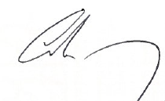
The Kerry ETB Corporate Compliance with Children First Act (2015) and the DES Child Protection Procedures for Primary and Post Primary Schools (2017) was formally approved by the Board of Kerry ETB on 23rd June 2021.

Mr. Colm Mc Evoy
Chief Executive Officer

List of Appendices

Appendix 1 Board of Management Agenda
Appendix 2 A Guide to Child Protection and Safeguarding Inspections
Appendix 3 Ten Overarching checks of Child Protection Inspections
Appendix 4 Key points on DES Inspections
Appendix 5 Flow chart in relation to CPS reporting arrangements for LCYP
Appendix 6 Flow chart in relation to CPS reporting arrangements for Music Generation
Appendix 7 Flow chart in relation to CPS reporting arrangements for SCP
Appendix 8 Parents Information Leaflet
Appendix 9 SLA between Kerry ETB and Funded Organisation (KDYS)

Appendix 10 General Reporting, Policy and Service Delivery Requirements

Appendix 11 Kerry ETB Emergency Contractor Entry Form

Appendix 1: Board of Management Agenda

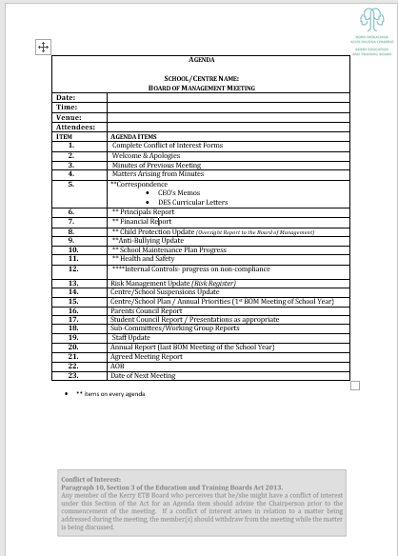

Appendix 2- A Guide to Child Protection and Safeguarding Inspections
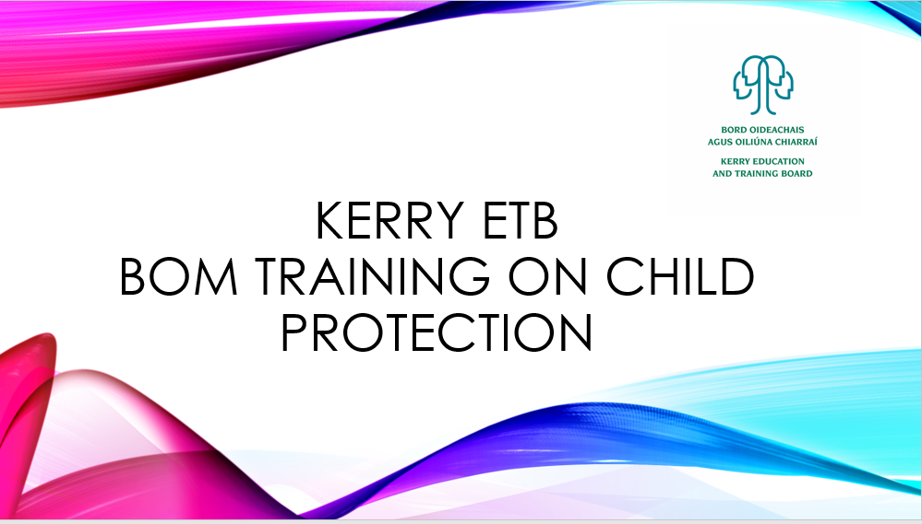
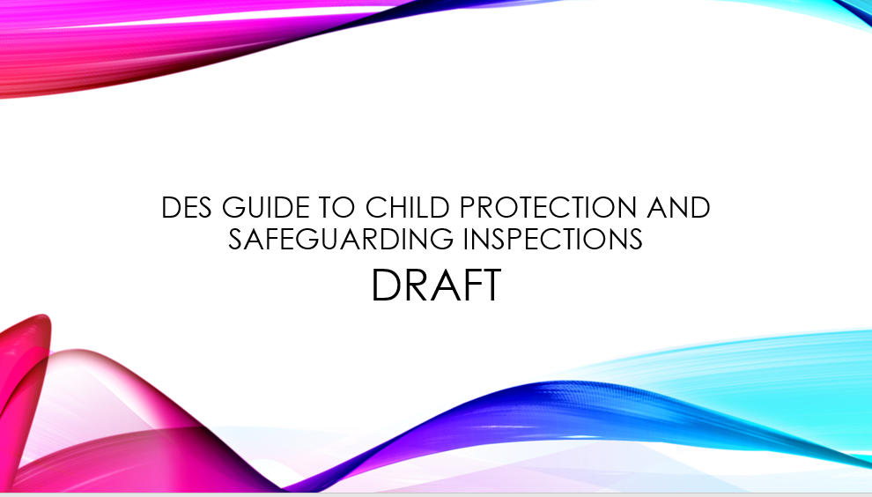

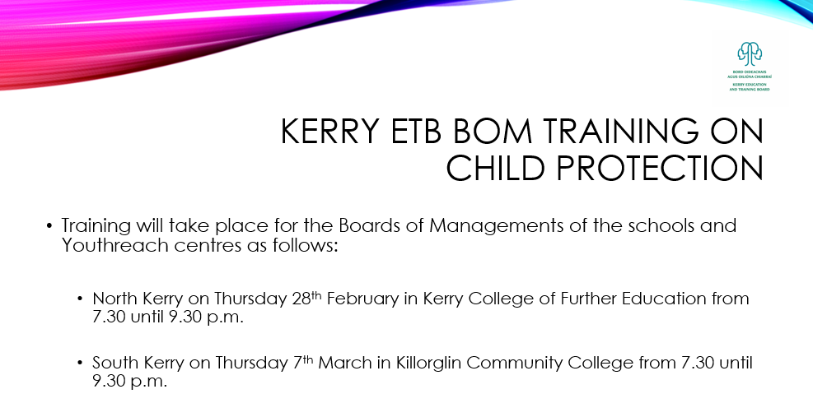
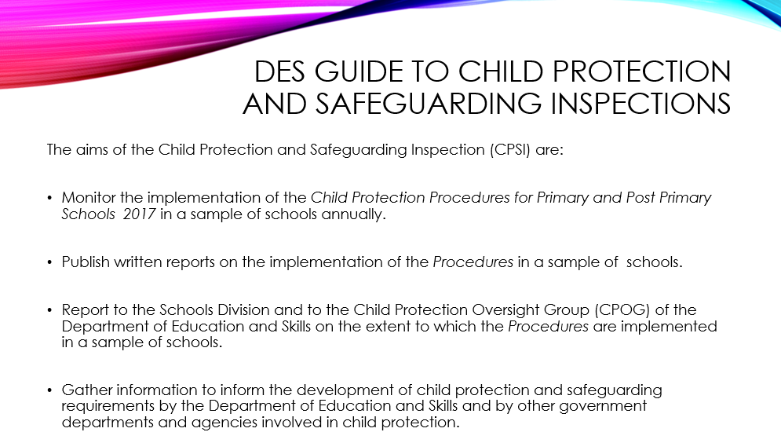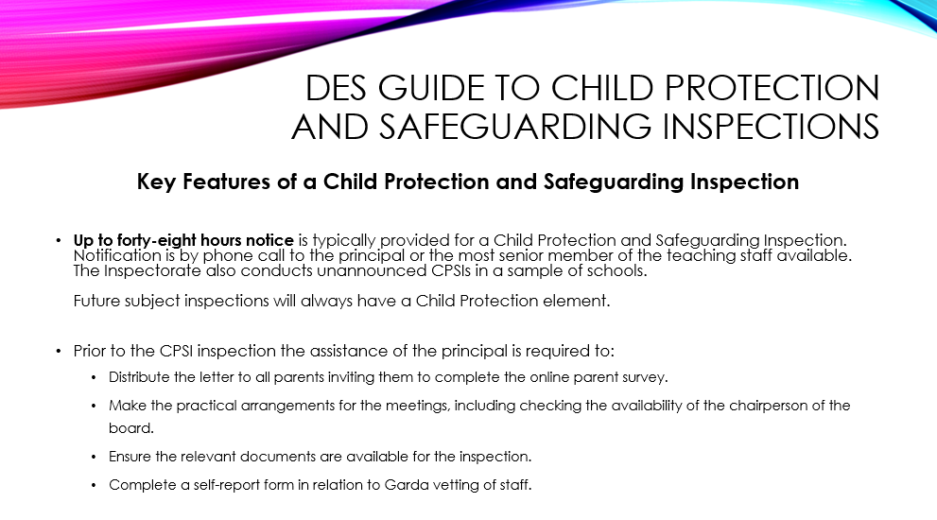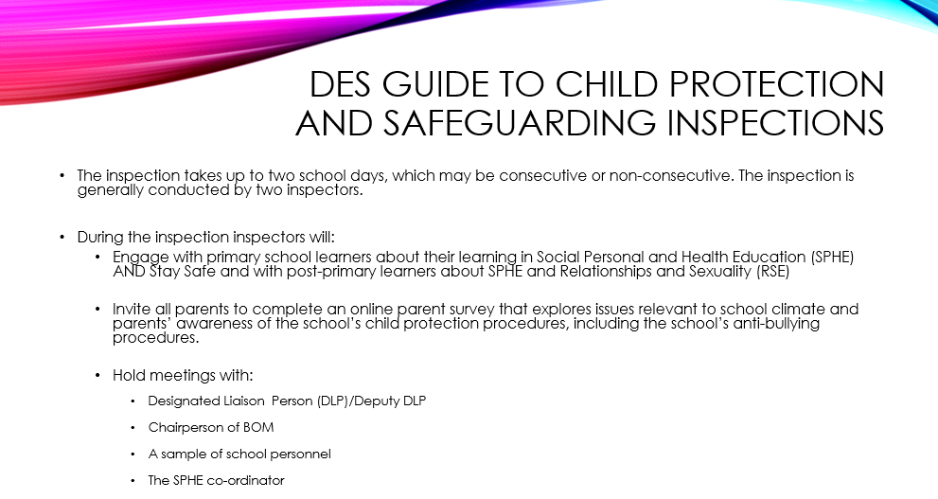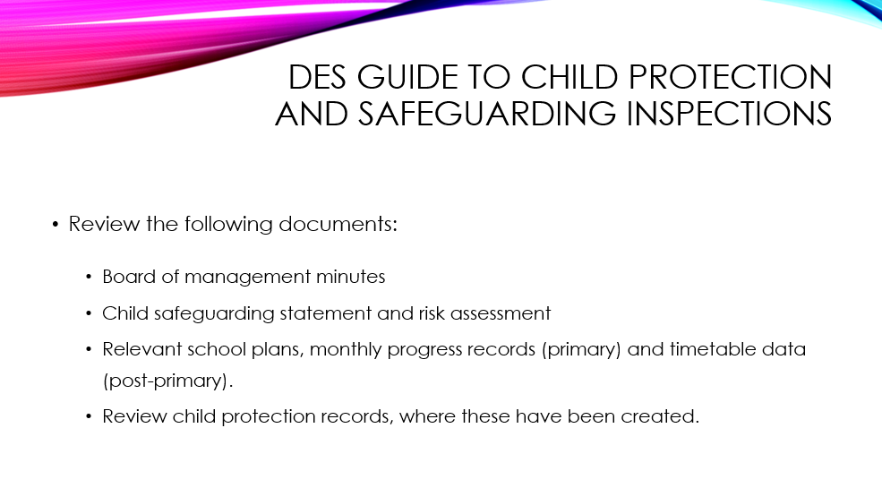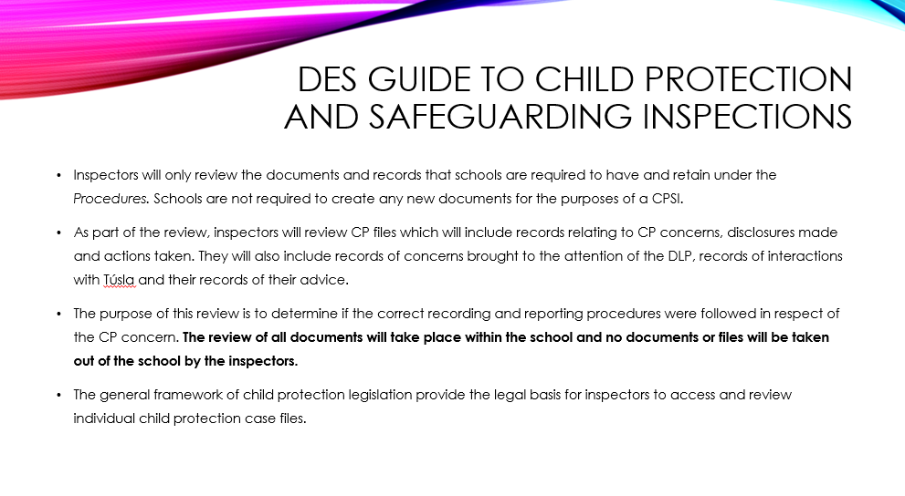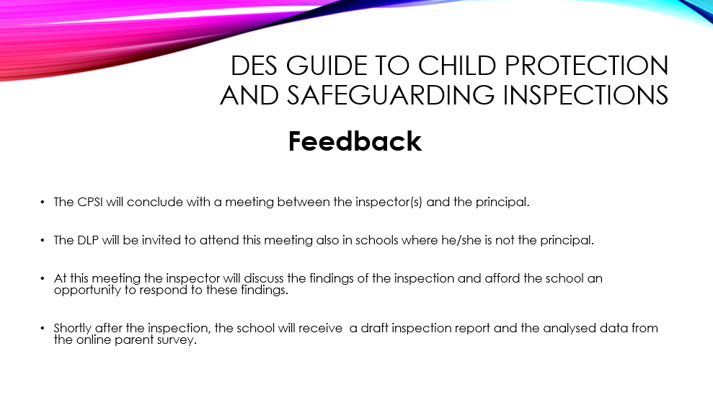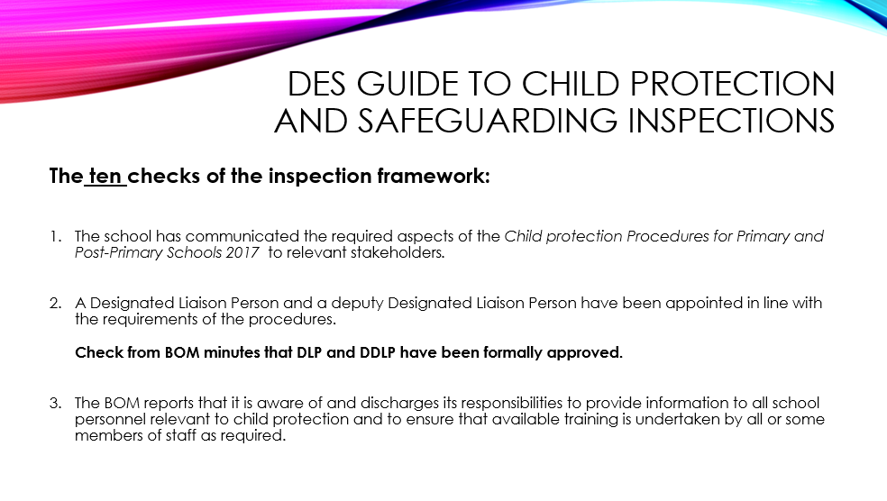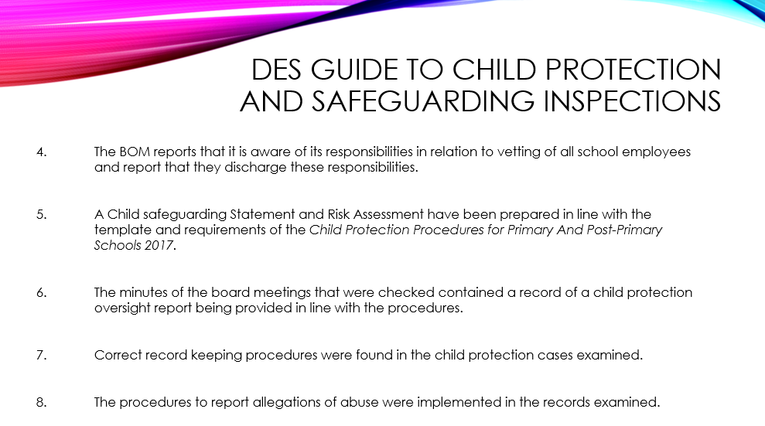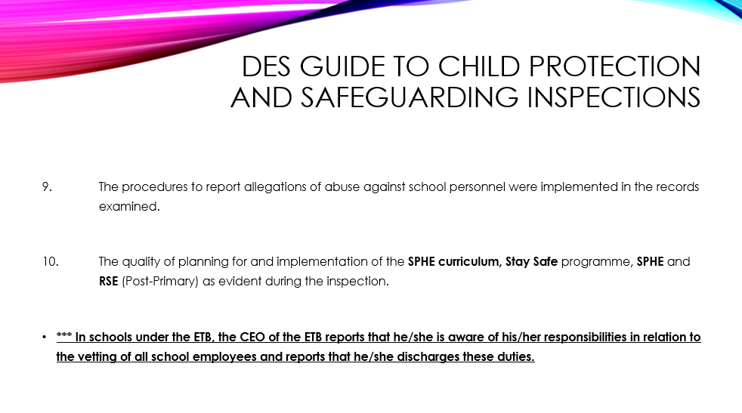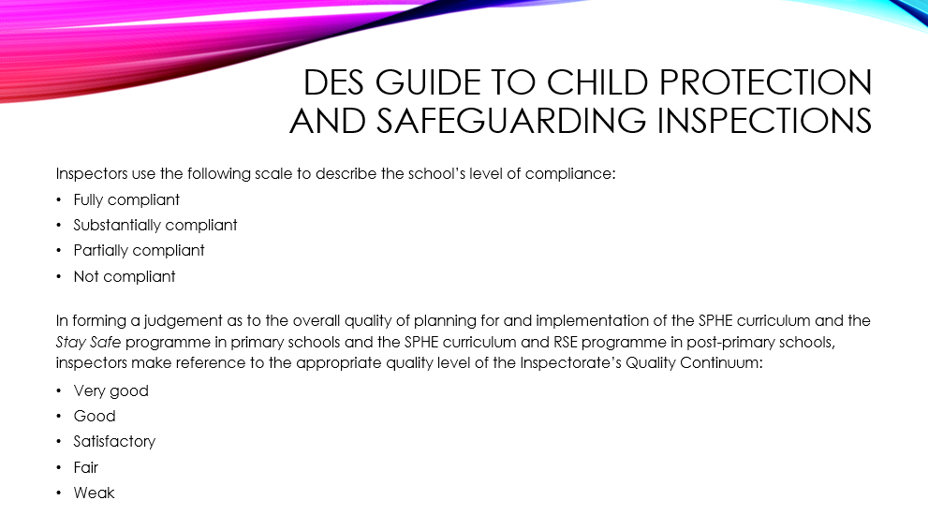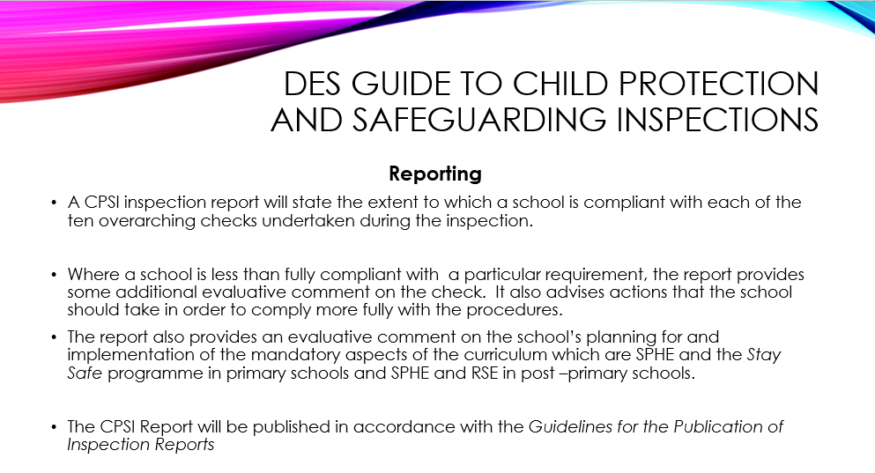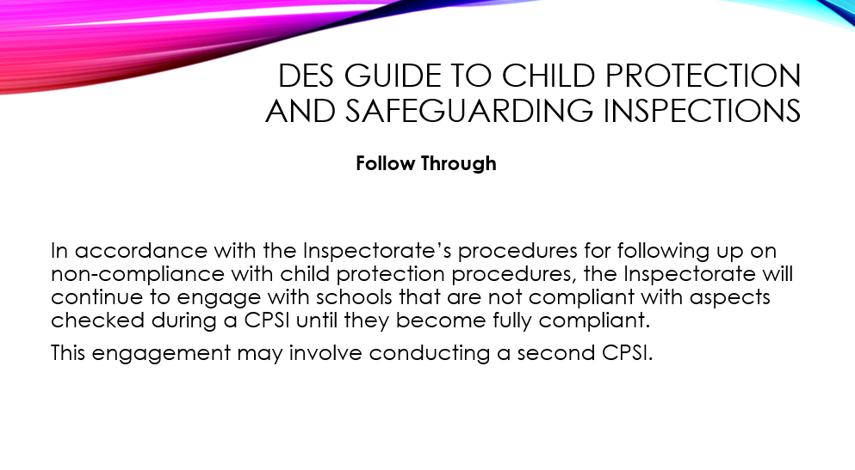

Appendix 3
The ten overarching checks of Child Protection Inspections
Note: Checks 1-3 will be included in Subject inspection

- The school has communicated the required aspects of the Child Protection Procedures to relevant stakeholders:

- The name of the DLP is displayed prominently near the main door of the school/in the reception area.
- The CSS is displayed in a prominent position near the main entrance.
- A copy of the CSS was provided to all school personnel.
- The RA is on display with CSS.
- The school have arrangements in place to make a copy of the CSS available to parents on request.
- A copy of the CSS was provided to the patron.
- A copy of the CSS was provided top the Parents’ Association.
- The CSS is published on the school’s website.
- School personnel are informed when a review of the CSS has taken place.
- The Parents’ Association receive written notification that the review of the school’s CSS has taken place (where no Parents’ Association exists, this notification is provided to the parents).
- A copy of the written notification that the review of the school’s CSS has taken place is placed on the school’s website.

- A DLP and DDLP in line with requirements of The Child Protection Procedures for Primary and Post-Primary Schools 2017:

- The minutes of the BOM record the fact that a DLP and DDLP have been appointed.
- The DLP and DDLP are current senior members of the full-time teaching staff.
- If the DLP is not the principal, the school authority has put arrangements in place to ensure that the DLP will keep the principal appropriately informed of child protection matters.

- The BOM reports that it is aware of and discharges its responsibilities to provide information to all school personnel relevant to child protection and to ensure that available training is undertaken by all and/or some members of staff as required.

- The BOM has arrangements in place to ensure that the DLP has the necessary familiarity with the Procedures to enable him/her to fulfil his/her responsibilities.
- The BOM has put arrangements in place to enable the deputy DLP to effectively assume his/her responsibilities in the absence of the DLP and to ensure that the deputy DLP can access relevant records when required.
- The BOM have arrangements in place to ensure that all school personnel have the necessary familiarity with Procedures to enable them to fulfil their responsibilities.
- All registered teachers who were interviewed as part of the interview with school personnel during the inspection were aware of the responsibilities of a mandated person.
- All members of school personnel who were interviewed as part of the interview with school personnel during the inspection were aware of the actions to take if they receive an allegation or have a suspicion that a child may have been abused or neglected, is being abused or neglected or is at risk of being abused or neglected.
- The BOM has arrangements in place to ensure that all members of the Board have the necessary familiarity with the Procedures to enable them to fulfil their responsibilities.

- The BOM reports that it is aware of its responsibilities in relation to vetting of all school employees and report that they did discharge these responsibilities.
(In schools under the ETB, the CEO of the ETB should replace the Chairperson of the BOM in all sub checks):
- The CEO of the ETB and the principal orally report that the ETB is aware of its responsibilities in relation to vetting of all school personnel and that they discharge these responsibilities.
- The CEO of the ETB and the principal sign the declaration that the ETB is aware of its responsibilities in relation to vetting of all school personnel and that they discharge these responsibilities.
- The CEO of the ETB and the principal confirm that all employees of the BOM are Garda Vetted.

- A Child Safeguarding Statement and Risk assessment have been prepared in line with the template and requirements of the Procedures:

- The CSS is in the format of the template provided in the appendix of the Child Protection Procedures for Primary and Post Primary Schools 2017.
- The CSS is reviewed annually.
- A record of the review and its outcome has been retained by the Board.
- If areas of improvement are identified in the review of the CSS, the school has put an action plan in place to deal with the issues.
- A risk assessment, having regard to the particular school’s context, has been completed based on the template provided with the Procedures.
- The school has specified in its written risk assessment, the policies and procedures in place to minimise the risk of harm by responding to potential risks.

- The minutes of board meetings checked contained a record of a child protection oversight report being provided in line with the requirements of the Procedures:

- The minutes of each BOM meeting that were checked contain a child protection oversight report.
- The child protection oversight report is on the template provided by the Dept. or contains all of the information required under each of the headings on the template.
- Where there are cases under Section 9.5 of the procedures (involving school personnel) the board was provided with all of the documents specified in section 9.5.2 of the procedures in respect of each such case.
- Where there were cases under section 9.7 of the procedures (not reported to Tusla) the board was provided with all of the documents specified in section 9.6.2 of the procedures in respect of each such case.
- The minutes of the BOM meeting use unique identifier numbers to refer to the individuals, including children, involved and do not record the names of the individuals involved.

- Correct record keeping procedures were found in the child protection cases examined:

- A hardcopy file is available for all child protection concerns which contains original records of the concern, all correspondence relevant to the concern and the names of all relevant individuals.
- All parties referenced in all files are assigned a unique identifier number.
- All files relevant to child protection are maintained in a secure location.
- The DDLP is aware of the location of the child protection files and can access them if required.

- The procedures to report allegations of abuse were fully implemented in the records examined:

- A written record from the DLP of how the concern came to his/her attention is retained on the relevant file for all concerns in respect of learners in the school.
- A copy of the report submitted to Tusla is available for all concerns that were reported to Tusla.
- A record of further action taken by the DLP and of any further communication with TUSLA, an Garda Siochana or other parties in relation to that report is available for all concerns that were reported to TUSLA.
- A record of the information communicated by the DLP to the parent/carer of the child about whom the report is being made to TUSLA or a record of the decision made by the DLP not to inform the parent/carer and the reasons for not doing so is available for all concerns that were reported to TUSLA.
- A record of any consultation with TUSLA, which includes the date, the name of the TUSLA official and the advice given is available for all concerns where the advice of TUSLA was sought and evidence that a report was submitted to TUSLA where TUSLA advised to do so.
- A record that the registered teacher* was informed that advice was being sought is available for all concerns where the advice of TUSLA was sought.
- A record that the registered teacher* was provided with the advice received is available for all concerns where the advice of TUSLA was sought.
- A report of a clear statement in writing provided to the staff member as to the reasons why the concern is not being reported and that the staff member was advised that he/she may still report that concern to TUSLA is available for all concerns that were not reported to TUSLA.

*In relation to this check: this requirement applies only where the concern was brought to the DLP’s attention by a registered teacher.

- The procedures to report all allegations of abuse against school personnel were fully implemented in records examined:

- A written record from the DLP of how the concern came to his/her attention is available in all cases of allegations made against a member of school personnel.
- A record that the school employer was informed is available in all cases of allegations made against a member of the school personnel.
- A record that the DLP sought advice from or made a report to TUSLA is available in all cases of allegations made against a member of the school personnel.
- A record that the DLP reported to TUSLA where TUSLA advised to do so.
- A record of the DLP’s notification under section 5.6 of the procedures to the parent informing him/her of whether or not the concern has been reported to TUSLA and if not, the reasons for not referring it is available if the allegation is made against school personnel by a parent.
- A record that the chair of the board of management/Chief Executive Officer of the ETB has assumed the role of the DLP to progress the case is available if the allegation is made against the DLP.
- A record that the school employer sought advice from or made a report to TUSLA is available if the allegation is made against the DLP.
- A record that TUSLA has been informed that the school’s protocol authorising immediate action has been operated is available.
- A record that the DLP sought advice from or made a report to TUSLA is available if the allegation is made against a member of the board.
- A record that the DLP reported tom TUSLA where TUSLA advised to do so
- .A record that the DLP informed the patron is available if the allegation is made against a member of the Board.
- A record that the Board informed the patron if they did not follow these reporting procedures is available in all cases of allegations made against a member of the school personnel.

- There is evidence of an implementation of an appropriate Social Personal and Health Education (SPHE) and Stay Safe Programme.

- There is a Social Personal and Health Education programme for all children in the school (primary).
- The Stay Safe programme is implemented within the school.
- There is an SPHE programme for all children in Junior Cycle (post primary check).
- There is a Relationships and Sexuality Education programme for all children in the school (post-primary check).
- Whole-school planning documents indicate that the school has planned appropriately for the implementation of the SPHE curriculum and the Stay Safe programme (primary).
- SPHE subject planning documents, RSE programme planning documents and school timetable information indicate that the school has planned appropriately for the implementation of the SPHE curriculum and the RSE programme (post primary check).
- The individual teacher planning documents reviewed indicate that the teachers are implementing the SPHE curriculum and the RSE programme (post primary check).
- The individual teacher planning documents reviewed indicate that the teachers are implementing the SPHE curriculum and Stay Safe programme appropriately (primary).
- The interactions with pupils indicate that the pupils have a satisfactory or better understanding of a number of the key topics of the SPHE and Stay Safe (primary) and SPHE and RSE (post primary).

Appendix 4
Key points on DES Inspections

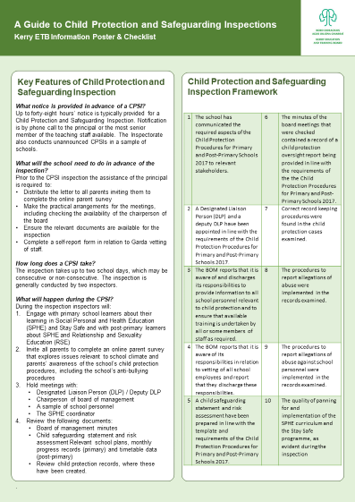

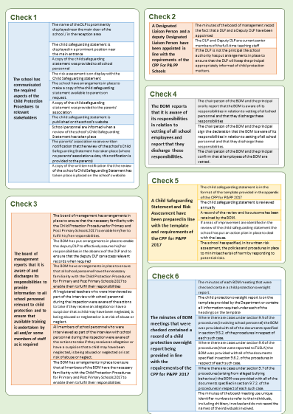

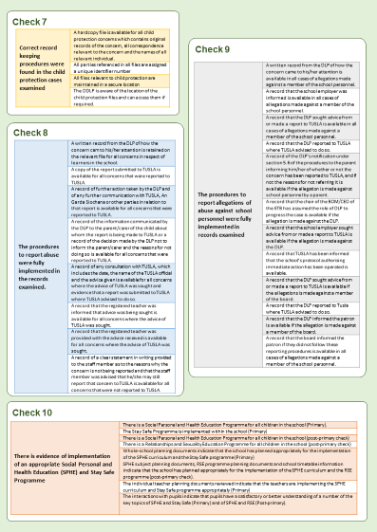

Appendix 5
Flow chart in relation to CPS reporting arrangements for LCYP
Local Creative Youth Partnership Child Protection Reporting Arrangements

In relation to activities and projects delivered in a section 44 governed/Board of Management school/centre reports are made in accordance with the existing policy and structures within that school/centre. However, in cases where a child protection issue arises involving an activity or project outside a section 44 governed school/centre the following reporting process applies.

Creative Youth Activities/projects
(For cases where a child protection issue arises involving an activity or project outside a section 44/ Board of Management governed school/centre the following reporting process applies).

DLP = Deirdre Enright
(Creative Youth Coordinator)
DDLP= Seamus Whitty
(Youth Development Officer)

Reporting to Director of Schools, Youth and Music/Kerry ETB Board

Youth Work Committee
Child Protection as a standing item on each agenda
CPOR to be delivered at meetings
1
2
Appendix 6
Flow chart in relation to CPS reporting arrangements for Music Generation
Interim reporting measures for Music Generation
Discussions relating to the establishment of a Section 44 committee for Music Generation are ongoing. In the interim period the flowchart below demonstrates the reporting structures that are in place.
Where activities and projects are delivered in a section 44/ Board of Management governed school/centre reports are made in accordance with the existing policy and structures within that school/centre. However, in cases where a child protection issue arises involving an activity or project outside a section 44 governed school/centre the following reporting process applies.

Music Generation Activities/Projects
(in cases where a child protection issue arises involving an activity or project outside a section 44/ Board of Management governed school/centre the following reporting process applies).

1
2
DDLP= Seamus Whitty

Director of Schools, Youth and Music

DLP = Deirdre Johnson*
(Music Development Officer)
Single Manager= Seamus Whitty
Child Protection as a standing item on each agenda
CPOR to be delivered at meetings
Director of Schools, Youth and Music

Appendix 7
Flow chart in relation to CPS reporting arrangements for SCP

All activities/projects that are delivered within section 44/ Board of Management governed school/centres are bound by the agreed CPS processes within those schools and centres.
Where activities and projects are delivered in a section 44/ Board of Management governed school/centre reports are made in accordance with the existing policy and structures within that school/centre. However, in cases where a child protection issue arises involving an activity or project outside a section 44 governed school/centre the following reporting process applies.
SCP Activities/projects
In cases where a child protection issue arises involving an activity or project outside a section 44/ Board of Management governed school/centre the following reporting process applies**.

1
2
DDLP= Geraldine O’ Halloran
(Resource Worker)

DLP = Norma Thompson
(SCP Coordinator)

**NOTE: in the event of an allegation being made against the DLP (SCP Coordinator)- Kerry ETB will conduct the employer function as the SCP Coordinator is an employee of Kerry ETB.
In the event of an allegation being made against the DDLP (Resource Worker)- the LMC will conduct the employer function as the Resource Worker is employed by the LMC.
In either case the LMC will ensure the child protection and safeguarding matter is reported to Tusla in accordance with the Children’s First Act (2015)

LMC
The matter is reported to the LMC in a CPOR

Appendix 8
Parents Information Leaflet

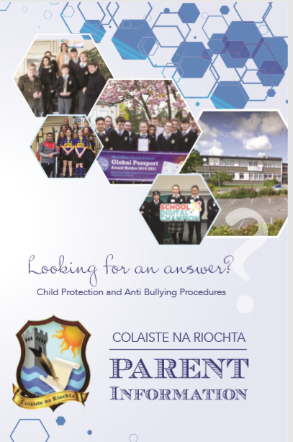

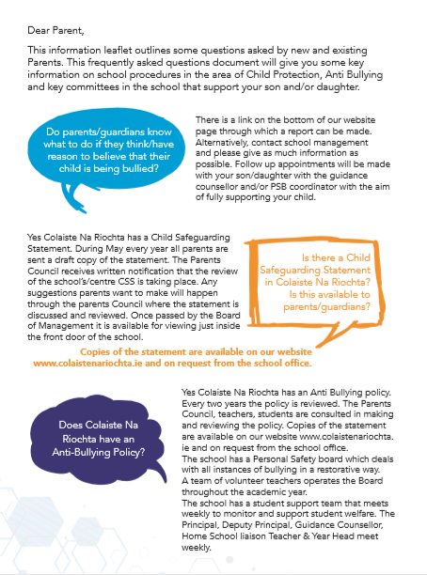

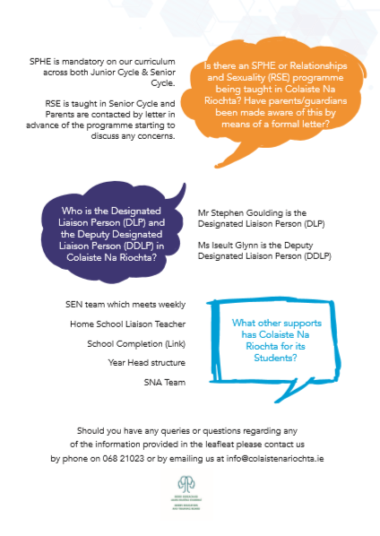

Appendix 9
SLA between Kerry ETB and Funded Organisation

Service Level Agreement between

Kerry Education and Training Board and Funded Organisation

Service Level Agreement
THIS AGREEMENT is made between [Insert organisation name] herein after known as the Funded Organisation and Kerry ETB herein after known as the ETB.
WHEREAS
The Department of Children and Youth Affairs (herein after known as the Grantor) has notified the ETB that a grant will be made available to the Funded Organisation for the amount specified by the Grantor. This amount will be made available solely for the purposes specified in the funding scheme for grant monies, herein after known as the funding scheme, to the above named Funded Organisation. The funds administered under this agreement are classified as grant aid. The Grantor has designated the ETB to administer the grant within the terms and conditions set out below. Appendices to this Service Level Agreement also detail conditions which must be adhered to as appropriate to the conditions of each funding scheme. This specific agreement refers to all Department of Children and Youth Affairs youth funding made available through the ETB to the Funded Organisation. For information, the range of funding schemes operated by the Grantor from 1 July 2020 are listed at Appendix 7.
TERM OF AGREEMENT
This agreement shall commence on 1 July 2020 and remain in place until such time as it requires a review and shall be reviewed if none takes place before the end of 31 December 2023. Any review will led by the Department of Children and Youth Affairs in consultation with all 16 Education and Training Boards.
PAYMENT OF THE GRANT
a) The grant received from the Grantor for the funding scheme will be paid by the ETB to the Funded Organisation under the terms of this Agreement in instalments and/or at the request of the Funded Organisation.
b) If this Agreement is renewed by the parties in subsequent years the grant will be paid to the Funded Organisation by the ETB after such grant has been received or a portion of same has been received from the Grantor under the same terms as (a) above.
c) The payment of funds is subject to the conditions of the funding scheme under which the grant is awarded which are considered to be part of this agreement.

NOW IT IS AGREED AS FOLLOWS
In pursuance of the said Agreement and in consideration of the Grant now paid or to be paid by the ETB to the Funded Organisation (the receipt whereof the Board hereby acknowledges) the Parties DO HEREBY COVENANT AND AGREE as follows:
The ETB will:
- Administer the grant to the Funded Organisations as agreed with the Grantor and in accordance with the terms of this Agreement.
- Carry out service, financial and any other additional monitoring of the Funded Organisation provided under the terms and conditions of the funding scheme and pursuant to this Agreement.
- Provide an assurance to the Grantor that the public funds provided are adequately accounted for and subject to the appropriate level of financial control by the Funded Organisation in accordance with Department of Public Expenditure and Reform Circular 13/2014.
- Provide assurance within this Agreement that the grant is not used as security for any other activity.
- Comply at all times with the terms of this Agreement for the duration of the Agreement.
- Provide support to the Funded Organisation pursuant to the ETB’s statutory role in relation to youth services to enable Funded Organisations to improve their governance structures, funded programmes and related services in the interests of young people, where resources allow.
- Assure itself that service providers are engaged in the National Quality Standards Framework.
The Funded Organisation will:
- Comply at all times with the terms of this Agreement for the duration of the Agreement.
- Fulfil service, financial and any other additional monitoring requirements provided for under the terms and conditions of the funding scheme and pursuant to this Agreement.
- Use the grant in a cost efficient and financially prudent manner solely for the purposes set out in the funding scheme.
- Obtain written approval for any change in the service delivery or use of the grant in accordance with this Agreement and the terms laid out in the attached appendices.
- Not distribute any of the grant monies or any of the proceeds raised in respect of any grant funded asset(s) amongst its members.
- Not use the grant monies for any purpose which shall directly or indirectly benefit the current or former officers or employees of the Funded Organisation or their relatives or dependents.
- Not, without prior notification, change its name (company/service), ownership, or executive control.
- Make appropriate acknowledgement of the funding source, including the ETB, the Department and comply as required under the terms and conditions of the funding schemes.
- Not use or expend any portion of the grant in circumstances which would represent a conflict of interest without prior written consent. A conflict of interest shall mean any interest (including the interest of a relative or person connected to the Funded Organisation) which could materially influence the Organisation in relation to service delivery or grant expenditure by reason of the fact that it might impinge, or might reasonably be deemed by other to impinge on the Funded Organisations impartiality in decision making in relation to service delivery or the expenditure of the grant.
- Not incur any indebtedness outside of the ordinary and proper course of the business of the Funded Organisation.
- Have prior to the date of this Agreement disclosed to the ETB all facts in relation to its business, undertakings, assets and affairs which ought to be properly made known to the Grantor and /or the ETB and which if so disclosed, might affect the willingness of the Grantor and/or the ETB to make available the Grant under the terms of this Agreement.
- Make available the financial records and related materials in respect of the grant provided for purposes of auditing, review and/or inspection by the ETB and/or the Grantor or the Comptroller and Auditor General, including any agents acting on their behalf.
- Provide reasonable access to personnel, documentation and data for the purposes of service or financial reviews in line with the requirements of the Grantor, and the obligations as set out in the DPER Circular 13/2014.
- Operate and deliver the funding scheme on an on-going basis to a satisfactory standard and shall maintain sufficient management capacity to operate the programme and shall implement and adhere to appropriate corporate governance standards.
- Ensure the clearly defined outputs for the funded organisation identified in the funding scheme are achieved and verifiable. The delivery should maximise potential outcomes for young people and demonstrates value for money.
- Not, without prior written consent, sub-contract the operation of the programme or any part of it, or align or assign, part with the possession or otherwise dispose of, mortgage or charge any property or other asset forming part of the programme or used in connection with the programme or subject of expenditure of the grant.
- To not in any way represent itself to be an agent of the Grantor and/or the ETB and acknowledges that it does not have the authority to enter into any obligations on behalf of the Grantor and/or the ETB or to bind the Grantor and/or the ETB in any way.
- Ensure that the execution of this Agreement has been duly authorised by the Board and constitutes valid legal and binding obligations on the Funded Organisation which are enforceable in accordance with the terms of this Agreement.
- Develop youth programmes and services in a culturally inclusive and appropriate manner.
- Engage with the National Quality Standards Framework.

RIGHT OF ACCESS
The Board of the Funded Organisation shall:
- Make available financial records and related materials relating to the grant provided for inspection, review, or audit upon request by the ETB and/or the Grantor, or Comptroller and Auditor General, or agents acting on their behalf, and permit reasonable access for the purposes of such inspection, review or audit.
- Permit any person authorised by the ETB and or the Grantor such reasonable access to its personnel, premises, facilities, policies, procedures and its programme records, for the purpose of monitoring and evaluating the programme for which Grant monies have been provided in accordance with this Agreement and shall, if so required provide appropriate oral or written explanations to them.

Dispute Resolution
The Parties agree to make every effort to avoid disputes involving the application of the SLA and to seek timely resolution of issues at the lowest level in the organisation as appropriate. Where a dispute has arisen, the following dispute avoidance and resolution process should be followed:

- Initially a formal meeting will be held between the relevant parties in relation to the issue.
- If appropriate the parties will agree a corrective and preventative action plan.
- Failing a resolution of the issue, the parties should seek mediation, arbitration or other equivalents to resolve the issue.
Where a breach or infringement by the Funded Organisation has, or the ETB has reason to believe may have taken place, refer to Appendix 6 of the SLA.

Force Majeure
If either party is prevented from fulfilling its obligations under this Agreement by reason of Force Majeure the party unable to fulfil its obligations shall immediately give notice of this to the other party and shall use reasonable endeavours to perform its obligations pursuant to this Agreement to the fullest extent practicable with a view to minimising any disruption in the continuity of services. Neither party shall be deemed to be in breach of its obligations under this Agreement in the event of being unable to perform its obligations due to Force Majeure. If and when the period of such incapacity exceeds 6 months then either party may serve notice to terminate this Agreement.

Information and data security measures
The ETB and the Funded Organisation must be compliant with General Data Protection Regulation (GDPR) and undertake periodic reviews to ensure full compliance. The ETB and the Funded Organisation must work together to ensure the following:
    - Information and data security is managed with reasonable efforts to restrict unauthorised access in accordance with relevant legislation.
    - Personnel are fully aware of the risks associated with information and data security issues in compliance with relevant legislation.
    - All data forms, e.g. application forms, are drafted and processed in accordance with relevant legislation.
NOTICES
Notices may be given by either party by hand, by letter or by email addressed to the other party at its address given and any such notice given by letter shall be deemed to have been given at the expiration of forty eight hours after the letter containing the same is posted.
FREEDOM OF INFORMATION ACT 2014
The Funded Organisation shall provide all reasonable assistance to enable the Grantor and/or the ETB to comply with their obligations under the Freedom of Information Act 2014. Should the Funded Organisation consider that any information or documents which are supplied are commercially sensitive, confidential or of a personal nature, the Funded Organisation, shall, at the time of providing the said information or documents, identify them and specify the reasons for their sensitivity. For the avoidance of doubt, nothing in this Agreement shall be regarded as giving rise to an automatic duty of confidence on the part of the Grantor and the ETB for the purposes of Section 35(1) (b) of the Freedom of Information Act 2014.
COPYRIGHT
The ETB and/or the Grantor retain their respective ownership rights to any or all intellectual property provided. Such intellectual property cannot be reproduced or distributed without permission. This does not affect the ownership of any background intellectual property which is shared between the parties in furtherance of this Agreement and which may be used by the parties for this purpose. This includes but is not limited to procedure manuals, policy documents, evaluation reports, programme reviews or value for money/return on investment studies.
PROPER LAW
This agreement shall be governed by and construed in accordance with the laws of the Republic of Ireland.
DISCLAIMER
The parties acknowledge that the amount of the grant made available in future years will be as determined by the Grantor. All funding is on an annual basis and dependent on availability of funding to the Grantor through government processes.

STATEMENT OF ASSURANCE
The signing of this Service Level Agreement constitutes a statement of assurance by the Board of the Funded Organisation and the ETB that all of the conditions contained within this Agreement and the appendices will be complied with in full. This applies to all monies paid to the Funded Organisation within the Terms of this Agreement.
SIGNED on behalf of THE BOARD of the Funded Organisation by:

Signature:
(Chair or duly authorised) Block Capitals
Position: Date:
SIGNED on behalf of ETB by:

Signature:
(Chief Executive or duly authorised) Block Capitals
Position: Date:
IMPORTANT Please note following:
There are two copies of the Agreement attached.
Please return both signed agreements to the ETB. One will be returned for your own records.

Appendix 10

General Reporting, Policy and Service Delivery Requirements
5.1. Reporting Requirements
The Funded Organisation must:
- Fulfil the reporting procedures determined by Kerry ETB and the relevant Grantor.
- Maintain adequate records and minutes recording all decisions made by the Board.
- Maintain a register of all:
  - Young people/adults who are engaged with the programmes/services provided by the funded organisation.
  - Staff, volunteers and students.
  - Staff designated ‘Mandated Persons’ under the Children First Act 2015.
- Maintain an up-to-date risk register.
- Maintain detailed records in relation to all health and safety issues arising and any claim threatened or made in relation to any alleged loss or damage by any other person including personnel.
- Complete the Organisation Information Update Form (PSIU) in full and reflect a true and accurate record of the Funded Organisation.
- Provide a Statement of Assurance that the Funded Organisation has a Garda Vetting Policy and are implementing it fully in respect of all staff and volunteers.
- Provide a Statement of Assurance that the Funded Organisation has a Safe Guarding Statement in place and that the policy is fully implemented.
- Submit an annual progress report on all the programmes funded as per the requirements of the Grantor.
5.2. Policy Requirements
The Funded Organisation must have in place key policies and procedures for the effective governance and delivery of Youth Work Services including the following:
- Health and Safety Policy including a Health and Safety Statement
- A Child Safeguarding Statement including written policy and procedures in accordance with the requirements of the Children First Act 2015.
- Garda Vetting Policy including a statement and written guidelines/procedures for the management of issues/concerns.
- Volunteer Policy and Procedures.
- Drug and Alcohol Policy and Procedures.
- Policies relating to the main areas of work e.g. group work, residential trips.
- A Charter of Rights for young people.
- Financial Management Procedures.
- Human Resources (HR) Policy and Procedures.
- Operations Policy and Procedures Manual.
- Data Protection policy.
- Risk Management policy and procedures.
5.3. Training Requirements
The Funded Organisation must:
- Ensure that all staff and volunteers complete Child Protection and Welfare Training deemed necessary to fulfil their role within an agreed time frame.
- Ensure that all volunteers complete Child Protection and Welfare Training deemed necessary to fulfil their role within an agreed time frame.
- Ensure that the Designated Liaison Person (DLP) for Child Protection (and Deputy DLP as required) complete any training considered necessary to fulfil their role in an agreed time frame.
- Ensure that all nominated persons who act as the link with the YWI Vetting Liaison Person complete Garda vetting training.
5.4. Recruitment and Selection Requirements
The Funded Organisation should:
- Ensure that interview panels participating in a recruitment and selection process have received adequate training.
- Ensure that prior to appointment/employment all new staff and volunteers have satisfactorily completed the Garda Vetting Process and all other references have been checked.
- Ensure that all staff appointed prior to the introduction of Garda vetting in 2006 has satisfactorily completed the Garda Vetting Process.
- Nominate a designated person(s) to act as the link with the Youth Work Ireland Vetting Liaison Person.
- Establish and maintain a personnel file for each staff member.
- Issue and ensure a signed contract of employment exists for all staff reflecting the terms and conditions applicable.
5.5. Delivery of Service
The Funded Organisation must:
- Participate in the NQSF processes and address the outcomes.
- 2. Have clearly defined target groups which are specific to the relevant funding requirements. The methods of targeting should be clearly set out and have a defined rationale.
- Work with young people aged 10-24 years. Working within available resources, the plan should demonstrate how these young people/and or adults will be engaged by the Funded Organisation.
- Ensure that all staff and volunteers are aware of and comply with the Funded Organisation’s Child Protection and Welfare Policy, Procedures and Child Safeguarding Statement.
- Ensure that the plan demonstrates that youth workers employed by the Funded Organisation are engaged in direct contact time with young people for at least 70% of their working time as appropriate.
- Ensure that the Service is open at times when young people are available prioritising evenings (7pm onwards), weekends and school holidays.
SIGNED on behalf of THE BOARD by

Signature:
(Duly authorised) Block Capitals
Position: Date:

Appendix 11
Kerry ETB Emergency Contractor Entry Form
Preamble
It is the policy of Kerry ETB to ensure that all contractors accessing Kerry ETB facilities with children present on-site, are Garda vetted.

In exceptional circumstances where unforeseen, essential and emergency work of an immediate nature arises and only an unvetted contractor is available. The unvetted contractor may be engaged by the Facility Manager.

In all cases where a contractor is employed by a school/centre, and there are children on site, an Emergency Contractor Entry Form should be completed.
Name of contractor
Address of contractor
Telephone number
Email address

Please tick the appropriate box
I confirm that I am Garda Vetted
I confirm that I am not Garda Vetted

I understand that I am not permitted to access to any areas of the building without the supervision of an assigned staff member
Signature of the Contractor

Please note: that this procedure is in compliance with the Kerry ETB Child Protection and Safeguarding Oversight Policy and in accordance with the Children’s First Act (2015) and/or the Child Protection and Safeguarding Procedures for Primary and Post-primary Schools (2017).

The Inspectorate will (as of October 1st, 2020) also ask for a copy of the Acceptable Usage Policy (AUP) and will discuss with the school principal if the school’s AUP outlines the school’s approach to remote or distance learning and how the school informs parents of their approach.
Please note appendix 5: flowchart in relation to child protection and safeguarding reporting arrangements for LCYP. Please note appendix 6: flowchart in relation to child protection and safeguarding reporting arrangements for Music Generation.
Source: DCYA Letter of February, 2018).
An exemplar SLA is attached as appendix 14
Source: The Department Information Memo for ETBs and National Youth Organisations Guidance Note for the Local Youth Club Grant Scheme 2021
Please note appendix 7: Flow chart in relation to child protection and safeguarding reporting arrangements for SCP
Facility Manager: Refers to Any Principal/Centre Manager/ Co-Coordinator who has responsibility for managing a Kerry ETB Premises/Facility.

