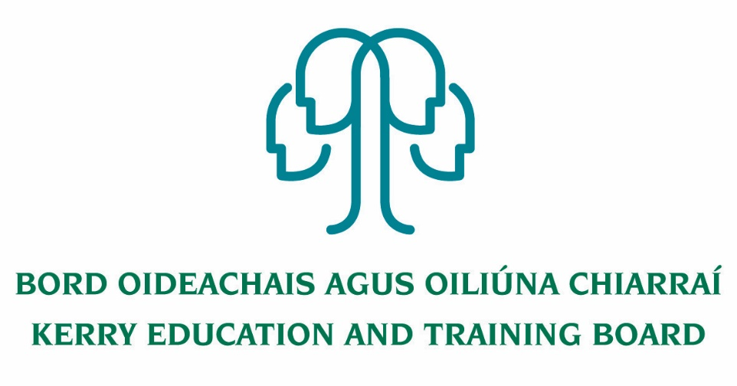

Revision 2. 12 /02/21.

Privacy Notice to Learners, Students (and their parents/guardians)

By applying for and/or attending a Kerry ETB school, centre, course or programme, you acknowledge that your personal data (including special category personal data) shall be processed by Kerry ETB. This Privacy Notice gives you some helpful information about who we are, what personal data we collect about you, why, who we share it with and why, how long we keep it, and your rights. If you need more information, please see our Data Protection Policy available at www.kerryetb.ie

- We are Kerry Education and Training Board (Kerry ETB).
Our address and contact details are:
Kerry ETB, Kerry ETB, Centrepoint, John Joe Sheehy Road, Tralee, Co. Kerry V92 P2FE. Tel. 066-7193900. Email: info@kerryetb.ie.

We provide primary level education, post-primary level education, including apprenticeships; Youthwork, community-based education programmes; outdoor education & training; outreach programmes, specialist programmes and other programmes/courses as maybe delivered/funded/sponsored in whole or part or in co-operation with other bodies/agencies etc. For further information, see section 1 of our Data Protection Policy available at www.kerryetb.ie.

- When you are a learner or student with Kerry ETB, we collect and use your personal data. The type of information we collect about you depends on various factors, such as whether you are under 18-years or an adult learner, the type of course you are enrolled on etc. The personal data we collect can include information about your identity and contact details; images/photo (including CCTV); family details; admission/enrolment details; previous schools; academic progress; PPS number; special educational needs; nationality; language; religion; medical data; information about behaviour and attendance; information about health, safety and welfare; financial information (re fees, grants, scholarships etc.); and other personal data. Further details of the data we collect about you can be found in section 2 of our Data Protection Policy. If you are under 18 years when you enrol, we collect the name, address, contact details and other information about your parents/guardians. If you are under 18 years, your parent/guardian is consulted and asked to give consent for certain things like taking your photograph, going on school trips etc. We use your personal data for purposes including: your application for enrolment; to provide you with appropriate education and support; to monitor your academic progress; to care for your health and well-being; to care for our staff, learners and students; to process grant applications and scholarships; to coordinate, evaluate, fund and organise educational programmes; to comply with our legal obligations as an education body; to comply with our monitoring and reporting obligations to Government bodies, and EU funding bodies; to process appeals, resolve disputes, and defend litigation etc. For further information on what data we collect, why we collect it, how we use it, and the legal basis for same, please go to section 2 of our Data Protection Policy available at www.kerryetb.ie.
Revision 2. 12 /02/21.
- We share your personal data with third parties, including other Government bodies. This includes the State Examinations Commission, the Department of Education and Skills, NCSA, NCSE and/or NEPs SOLAS, SUSI, HEA, QQI, the Private Security Authority, Turnitin, TUSLA, Comptroller & Auditor General, Internal Audit Unit – ETBs (IAU-ETBs), An Garda Síochána, HSE, the Department of Social Protection, the Revenue Commissioners etc. The level of sharing and the nature of what is shared depend on various factors, including the nature of the course you are undertaking/enrolled on. The Government bodies to which we transfer your personal data will use your personal data for their own purposes (including: to verify other information they already hold about you, for fraud prevention measures, etc.) and they may aggregate it with other information they already hold about you and your family. We also share your personal data with other third parties including our insurance company and other service providers (including IT providers, security providers, legal advisors etc.), and other schools/colleges and bodies in the further education and training sector, apprenticeship providers, work-experience placements and future employers etc. We are legally required to provide certain records relating to the progress of a student (under 18 years) in his/her education to the student’s parents/guardians, including results of examinations. For further information on who we share your data with, when and in what circumstances, and why, please see section 3 of our Data Protection Policy available at www.kerryetb.ie

- We do not transfer your personal data to a third country or international organisation.

- We do not engage in automated decision making/profiling.

- Some personal data is only kept for a short period. Some data we retain for a longer period. For further information on the retention periods, please go to section 6 of our Data Protection Policy available at www.kerryetb.ie.

- You have the following statutory rights that can be exercised at any time:
  - Right to complain to supervisory authority.
  - Right of access.
  - Right to rectification.
  - Right to be forgotten.
  - Right to restrict processing.
  - Right to data portability.
  - Right to object and automated decision making/profiling.
For further information, please see section (7) of our Data Protection Policy available at www.kerryetb.ie.

- Please contact the Data Protection Officer, Kerry ETB, in relation to Data Protection.
Tel. 066-7193900.
Email: dataprotection@kerryetb.ie.

If you have any queries, please consult our Data Protection Policy (available at www.kerryetb.ie) or contact the Corporate, Capital & Technology Department, Kerry ETB.

Revision 2. 12 /02/21.

Revision 1. 30/06/20

Privacy Notice to Staff, Board Members, Committee members and Volunteers
By applying for any position, working or volunteering with, or otherwise taking up any position within Kerry ETB, you acknowledge that your personal data (including special category personal data) shall be processed by Kerry ETB. This Privacy Notice gives you some helpful information about who we are, what personal data we collect about you, why, who we share it with and why, how long we keep it, and your rights. If you need more information, please see our Data Protection Policy available at www.kerryetb.ie

- We are Kerry Education and Training Board (Kerry ETB).

Our address and contact details are Kerry ETB, Centrepoint, John Joe Sheehy Road, Tralee, Co. Kerry V92 P2FE. Tel. 066-7193900. Email: info@kerryetb.ie.

We provide primary level education, post-primary level education, second chance education; further education and training including apprenticeships; Youthwork, community-based education programmes; outdoor education & training; outreach programmes, specialist programmes and other programmes/courses as maybe delivered/funded/sponsored in whole or part or in co-operation with other bodies/agencies etc. For further information, see section 1 of our Data Protection Policy available at www. kerryetb.ie

- We collect and use your personal data. The personal data we collect includes your name; date of birth; address; contact details; CV and qualifications; vetting outcome; Teaching Council registration; registration with any other professional/accrediting body; PPS number; financial data; images (staff cards, CCTV); medical, health and occupational health data; immigration/work-visa information; information relating to recruitment, promotions, and appointments processes; other IR/HR processes; pensions details etc. We use personal data for purposes including: running an efficient service; complying with our obligations as an employer; for recruitment and appointments; allocating resources to our education centres; monitoring the effectiveness of our equal opportunities statement; to discharge our duties to other staff and students; complying with our statutory reporting obligations to Government bodies and EU funding bodies; resolving disputes and defending litigation etc. The information we collect about you depends on various factors, e.g. we will hold differing levels of information about a job applicant as compared with a long-standing staff member. Certain personal data is collected and aggregated for use on an anonymised basis, e.g. to monitor our compliance with equal opportunities and non-discrimination policies. For further information on what data we collect, why we collect it, how we use it, and the legal basis for same, please go to section 2 of our Data Protection Policy available at www.kerryetb.ie.
Revision 1. 30/06/20

- We share your personal data with third parties, including other Government bodies. Depending upon the nature of your role within the ETB, this may include data-sharing with bodies including the Department of Education and Skills, Revenue Commissioners, Department of Social Protection, Comptroller & Auditor General, Internal Audit Unit – ETBs (IAU-ETBs), (TUSLA, An Garda Síochána, HSE, the Teaching Council or any other regulatory body to which you belong, your Trade Union (for IR/HR issues), occupational health advisors, our insurance company (Irish Public Bodies), banks/financial institutions (to pay wages), pension administrators and pension trustees, future employers (for references etc.), other service providers (including IT providers, security providers, legal advisors) etc. The Government bodies to which we transfer your personal data will use it for their own purposes (including: to verify other information they already hold about you, for fraud prevention measures, etc.) and may aggregate it with other information they already hold about you. For further information on who we share your data with, when and in what circumstances, and why, please see section 3 of our Data Protection Policy available at www.kerryetb.ie.

- We do not transfer your personal data to a third country or international organisation.

- We do not engage in automated decision making/profiling.

- Some personal data is only kept for a short period (e.g. we will destroy at the end of an academic year because it is no longer needed). Some data we retain for a longer period (e.g. we retain even after you leave our employment). For further information on the retention periods, please go to section 6 of our Data Protection Policy available at www.kerryetb.ie.

- You have the following statutory rights, that can be exercised at any time:
(a) Right to complain to supervisory authority.
  - Right of access.
  - Right to rectification.
  - Right to be forgotten.
  - Right to restrict processing.
  - Right to data portability.
  - Right to object and automated decision making/profiling.
For further information, please see section (7) of our Data Protection Policy available at www.kerryetb.ie , or alternatively contact, on an interim basis, CS&CD Department, Kerry ETB.

- Please contact the Data Protection Officer, Kerry ETB, in relation to Data Protection.
Tel. 066-7193900.
Email: dataprotection@kerryetb.ie.

If you have any queries, please consult our Data Protection Policy (available at www.kerryetb.ie) or contact the CS&CD Department, Kerry ETB.

Revision 1. 30/06/20

